Bangladesh Medical Association (BMA)
List of Life Member-393
12. BMA Cumilla Branch

Sl No | Voter No | Voter Details
1 | Voter No  LM-1200001  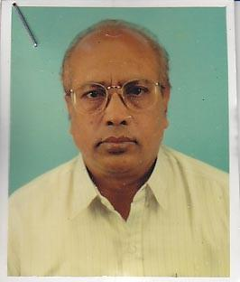 | DR. MD. HIDAYETULLAH  F/Name: Late Moulavi Mokbul Ahmed  M/Name:  BM & DC Reg. No:  NID:  Cell:  Address: Sheba Ghar Ramghat Comilla  Blood Group:
2 | Voter No  LM-1200002  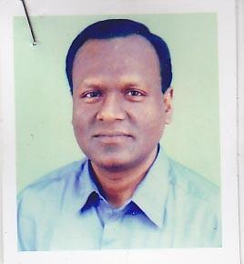 | DR. MUSLEHUDDIN AHMED  F/Name: Late Md. Jonab Ali  M/Name:  BM & DC Reg. No:  NID:  Cell:  Address: Eastern Medical Hall Kandirpar Comilla  Blood Group:
3 | Voter No  LM-1200003  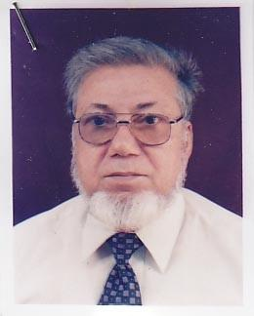 | DR. MUHAMMED SHAMSUL ALAM  F/Name: Late Moulana Amin Ullah  M/Name:  BM & DC Reg. No:  NID:  Cell:  Address: Near Income Tax Office, Comilla  Blood Group:
4 | Voter No  LM-1200004  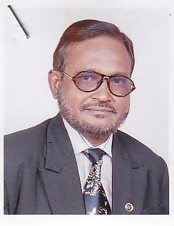 | DR. MD. SHAHID ULLAH  F/Name: Late Md. Atiqullah Bhuiyan  M/Name:  BM & DC Reg. No:  NID:  Cell:  Address: Chartha, Taltala, Comilla.  Blood Group:
5 | Voter No  LM-1200005  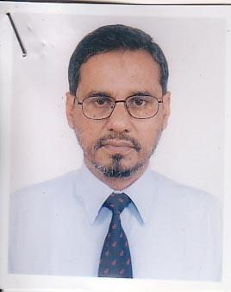 | DR. ABU AYUB HAMID  F/Name: Late A.i.m. Masiha  M/Name:  BM & DC Reg. No:  NID:  Cell:  Address: Court Road, Comilla.  Blood Group:
6 | Voter No  LM-1200006  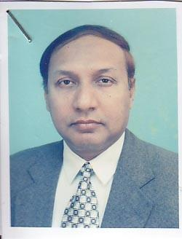 | DR. A.K.M. ABDUS SALIM  F/Name: Late Abdul Gafur  M/Name:  BM & DC Reg. No:  NID:  Cell:  Address: Medi. Complex (Pvt.) Jhawtala Comilla  Blood Group:
7 | Voter No  LM-12000069 | DR. MOHAMMAD KHURSHED ALAM  F/Name: Late Md. Shamsul Alam  M/Name:  BM & DC Reg. No:  NID:  Cell:  Address: Cumilla  Blood Group:
8 | Voter No  LM-1200007 | DR. MD. KHURSHED ALAM  F/Name: Prof. Golam Sobhan  M/Name:  BM & DC Reg. No:  NID:  Cell:  Address: Medi. Complex (Pvt.) Jhawtala, Comilla  Blood Group:
9 | Voter No  LM-12000078  No Image | DR. MOHAMMAD SYEED HOSSAIN "NELOY"  F/Name: Md. Mazhar Hossain  M/Name:  BM & DC Reg. No:  NID:  Cell:  Address: Cumilla  Blood Group:
10 | Voter No  LM-1200008  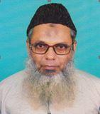 | DR. ABDUL MATIN PATWARY  F/Name: Late Dora Ali Patwari  M/Name:  BM & DC Reg. No:  NID:  Cell:  Address: TH & FPO Thana Health Complex Laksham,Comilla.  Blood Group:  E X P I R E D
11 | Voter No  LM-1200009  No Image | DR. MD. ABDUL ALIM  F/Name:  M/Name:  BM & DC Reg. No:  NID:  Cell:  Address: Senior Consultant (ENT) Chittagong General Hospital Chittagong  Blood Group:  TRANSFERED to BMA Dhaka City  LM-1405543
12 | Voter No  LM-1200010  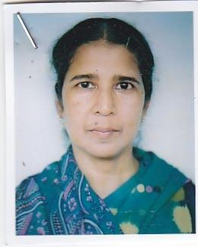 | DR. ROKEYA BEGUM  F/Name: Late Faizur Rahman  M/Name:  BM & DC Reg. No:  NID:  Cell:  Address: Medical Officer Thana Health Complex Laksham, Comilla.  Blood Group:
13 | Voter No  LM-1200011  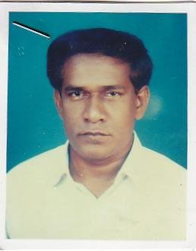 | DR. ABUL HASHEM ANSARI  F/Name: Late Md. Ansar Ali  M/Name:  BM & DC Reg. No:  NID:  Cell:  Address: Asstt. Surgeon, Jail Hospital, Comilla.  Blood Group:
14 | Voter No  LM-1200012  No Image | DR. A.K.M. RAZZAQUE  F/Name: Late Abdul Wadud  M/Name:  BM & DC Reg. No:  NID:  Cell:  Address: Midland Hospital Goli Ramghat Comilla  Blood Group:
15 | Voter No  LM-1200013  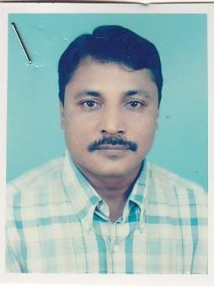 | DR. MD. ALI AKBAR  F/Name: Md. Arshadur Rahman  M/Name:  BM & DC Reg. No:  NID:  Cell:  Address: Consultant (Surgery) General Hospital Comilla.  Blood Group:
16 | Voter No  LM-1200014  No Image | DR. YAMIN HOSSAIN  F/Name:  M/Name:  BM & DC Reg. No:  NID:  Cell:  Address: Jr. Consultant (Anaes) Adhunik Hospital Comilla  Blood Group:
17 | Voter No  LM-1200015  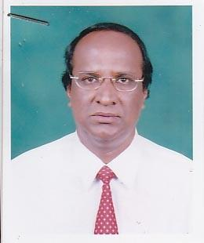 | DR. K.A. MANNAN  F/Name: Kazi Jainal Abedin  M/Name:  BM & DC Reg. No:  NID:  Cell:  Address: Sr. Consultant (Paed) General Hospital Comilla.  Blood Group:
18 | Voter No  LM-1200016  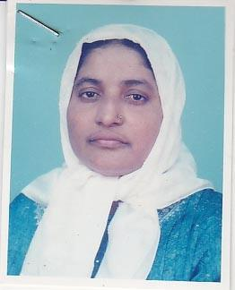 | DR. ARJUMAN NAHAR  F/Name: Late Abdul Sobhan Mondal  M/Name:  BM & DC Reg. No:  NID:  Cell:  Address: Jhawtala,Comilla  Blood Group:  E X P I R E D
19 | Voter No  LM-1200017  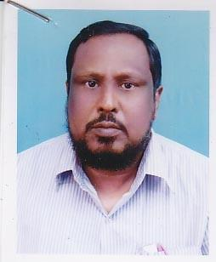 | DR. MOHSINUZZAMAN CHOWDHURY  F/Name: Late Naderuzzaman Chowdhury  M/Name:  BM & DC Reg. No:  NID:  Cell: 01711795702  Address: Pricipal, Comilla Medical College, Comilla.  Blood Group:
20 | Voter No  LM-1200018  No Image | DR. MD. SHAHABUDDIN  F/Name:  M/Name:  BM & DC Reg. No:  NID:  Cell:  Address: Dept. Of Medicine, Comilla Medical College, Comilla.  Blood Group:
21 | Voter No  LM-1200019  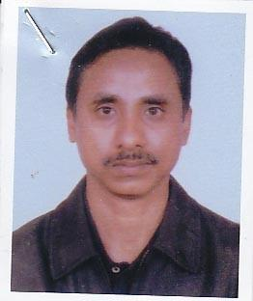 | DR. KHALED MAHMOOD  F/Name: Late A W M Toaha  M/Name:  BM & DC Reg. No:  NID:  Cell:  Address: Mahmood Lodge, Kandirpar, Comilla.  Blood Group:
22 | Voter No  LM-1200020  No Image | DR. NAZMA HOQUE  F/Name:  M/Name:  BM & DC Reg. No:  NID:  Cell:  Address: Lecturer, Anatomy Comilla Medical College Comilla  Blood Group:
23 | Voter No  LM-1200021  No Image | DR. MD. ZAKIR HOSSAIN BHUIYAN  F/Name:  M/Name:  BM & DC Reg. No:  NID:  Cell:  Address: Guenpur Health Complex Daudkandi, Comilla.  Blood Group:  E X P I R E D
24 | Voter No  LM-1200022  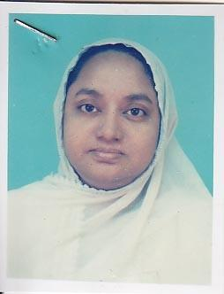 | DR. KAMRUN NAHAR  F/Name: Dr. Abdul Latif Bhuiyan  M/Name:  BM & DC Reg. No:  NID:  Cell:  Address: Shashasta, Jhowtala, Comilla.  Blood Group:
25 | Voter No  LM-1200023  No Image | DR. MD. LIAKAT ALI KHAN  F/Name: Late Janab Khan  M/Name:  BM & DC Reg. No:  NID:  Cell:  Address: Ananna Bishoapur Bhatpara Road Comilla  Blood Group:
26 | Voter No  LM-1200024  No Image | DR. MD. HUMAYUN KABIR PATWARY  F/Name:  M/Name:  BM & DC Reg. No:  NID:  Cell:  Address: Comilla  Blood Group:  E X P I R E D
27 | Voter No  LM-1200025  No Image | DR. N.M. SHAHJAHAN  F/Name: Late Tamij Uddin Ahmed  M/Name:  BM & DC Reg. No:  NID:  Cell:  Address: Al-Falah Police Line Comilla  Blood Group:
28 | Voter No  LM-1200026 | DR. IMAMUDDIN AHMED  F/Name: Late Dr. T.ali  M/Name:  BM & DC Reg. No:  NID:  Cell:  Address: C/O.-Dr. Begum T. Ali, North Charla, Comilla.  Blood Group:
29 | Voter No  LM-1200027  No Image | DR. DILIP KUMAR ROY  F/Name: Late Dinesh Ch. Roy  M/Name:  BM & DC Reg. No:  NID:  Cell:  Address: Moon Hospital Jhawtala Comilla  Blood Group:
30 | Voter No  LM-1200028 | DR. MD. GOLAM SAMDANI  F/Name: Late Dr. Abdur Rouf  M/Name:  BM & DC Reg. No:  NID:  Cell:  Address: Doctor's Chamber 2nd Kandirpar, Comilla.  Blood Group:
31 | Voter No  LM-1200029  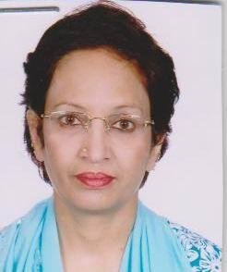 | DR. MRINALINI SHARMA  F/Name: Late Sethuraman  M/Name:  BM & DC Reg. No:  NID:  Cell:  Address: Doctor's Chamber Madina Masjid Road 2nd Kandirpar, Comilla  Blood Group:
32 | Voter No  LM-1200030  No Image | DR. A.K.M. FAKRUDDIN  F/Name:  M/Name:  BM & DC Reg. No:  NID:  Cell:  Address: Comilla Cottage Ind. Laksham Road Comilla  Blood Group:
33 | Voter No  LM-1200031  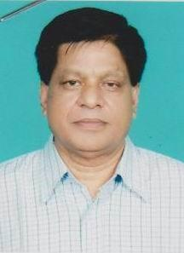 | DR. A B M. KHORSHED ALAM  F/Name: Late Ahmmed Hossain  M/Name:  BM & DC Reg. No:  NID:  Cell:  Address: Midland Hospital, Ramgati, Comilla.  Blood Group:
34 | Voter No  LM-1200032  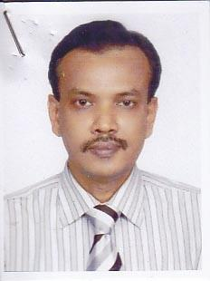 | DR. MD. KALIMULLA  F/Name: Alhaz Md. Abdul Gani  M/Name:  BM & DC Reg. No:  NID:  Cell:  Address: 83, Nazrul Avenue New Chowdhury Para Comilla  Blood Group:
35 | Voter No  LM-1200033  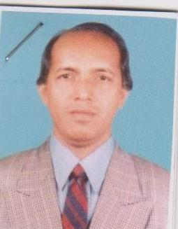 | DR. MD. REZAUL ALAM  F/Name: Late Md. Elias  M/Name:  BM & DC Reg. No:  NID:  Cell:  Address: Puratan Chowdhury Para, Comilla  Blood Group:
36 | Voter No  LM-1200034  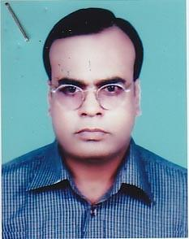 | DR. MD. DELWAR HOSSAIN  F/Name: Md. Abdul Hai  M/Name:  BM & DC Reg. No:  NID:  Cell:  Address: Radiologist, Sadar Hospital, Comilla.  Blood Group:
37 | Voter No  LM-1200035  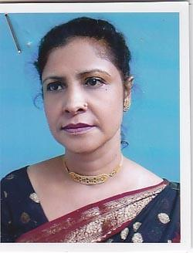 | DR. NEERA LAHIRY  F/Name: Mr. S.p. Lahiry  M/Name:  BM & DC Reg. No:  NID:  Cell:  Address: Jhawtala Comilla  Blood Group:
38 | Voter No  LM-1200036  No Image | DR. A K M. MASUD HASAN  F/Name: Late Dr. Mominul Hoque  M/Name:  BM & DC Reg. No:  NID:  Cell:  Address: 12, Prinee Road Jowtala Comilla  Blood Group:
39 | Voter No  LM-1200037  No Image | DR. MOHAMMAD ILIAS MIA  F/Name:  M/Name:  BM & DC Reg. No:  NID:  Cell:  Address: 178, Jhowtala Comilla  Blood Group:
40 | Voter No  LM-1200038  No Image | DR. MD. KHORSHED ALAM  F/Name: Late Meah Torab Ali  M/Name:  BM & DC Reg. No:  NID:  Cell:  Address: Raur Dighi (North) Monohorpur Comilla  Blood Group:
41 | Voter No  LM-1200039  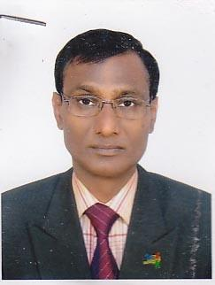 | DR. MD. JAHANGIR HOSSAIN BHUIYAN  F/Name: Serajul Islam Bhuiyan  M/Name:  BM & DC Reg. No:  NID:  Cell:  Address: Vill-Rajendapur Sadar Comilla  Blood Group:
42 | Voter No  LM-1200040  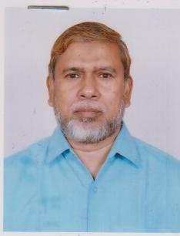 | DR. MD. JAHANGIR ALAM  F/Name: Md. Abul Hashem  M/Name:  BM & DC Reg. No:  NID:  Cell:  Address: Chartha Chowmohoni Comilla  Blood Group:
43 | Voter No  LM-1200041  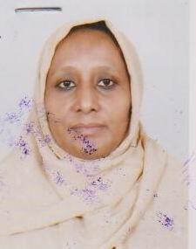 | DR. NASREEN AKTER BANU  F/Name: Late Shams Uddin Ahmed  M/Name:  BM & DC Reg. No:  NID:  Cell:  Address: Chartha Chowmohoni Comilla  Blood Group:
44 | Voter No  LM-1200042 | DR. MD. ATAUR RAHMAN  F/Name: Late Md. Abdul Gafur  M/Name:  BM & DC Reg. No:  NID:  Cell:  Address: Asstt. Prof. Surgery Comilla Medical College Comilla  Blood Group:
45 | Voter No  LM-1200043  No Image | DR. MD. ROFIUDDIN  F/Name:  M/Name:  BM & DC Reg. No:  NID:  Cell:  Address: Medical Officer Thana Health Complex Burichang, Comilla  Blood Group:
46 | Voter No  LM-1200044  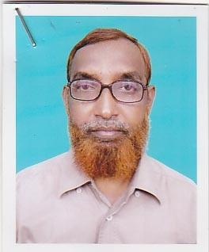 | DR. MD. SOFIQUR RAHMAN PATWARY  F/Name: Late Ali Nawab Patwary  M/Name:  BM & DC Reg. No:  NID:  Cell:  Address: Consultant (Ortho) General Hospital Comilla  Blood Group:
47 | Voter No  LM-1200045  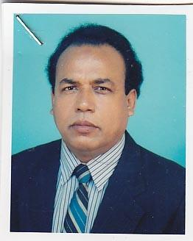 | DR. MD. AKTHARUZZAMAN  F/Name: Late Hazi Adam Ali  M/Name:  BM & DC Reg. No:  NID:  Cell:  Address: Plot-8, Block-H, Section-2 H/S Comilla.  Blood Group:
48 | Voter No  LM-1200046  No Image | DR. MD. MAJIBUR RAHMAN  F/Name: Late Yakub Ali  M/Name:  BM & DC Reg. No:  NID:  Cell:  Address: Gomati Diognostic Lab Kandirper Comilla  Blood Group:
49 | Voter No  LM-1200047  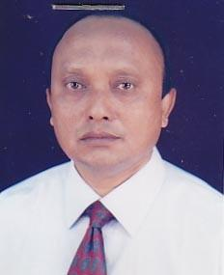 | DR. MOHAMMAD KASEM  F/Name: Late Abdus Suban Monshi  M/Name:  BM & DC Reg. No:  NID:  Cell:  Address: Gomati Diognostic Lab Kandirper Comilla  Blood Group:
50 | Voter No  LM-1200048  No Image | DR. MIR ABDULLAH  F/Name: Late Mir Solaiman  M/Name:  BM & DC Reg. No:  NID:  Cell:  Address: TH & FPO Thana Health Complex Barura Comilla  Blood Group:
51 | Voter No  LM-1200049 | DR. MD. IQBAL ANWAR  F/Name: Khabir Uddin Ahmed  M/Name:  BM & DC Reg. No:  NID:  Cell:  Address: Khonika South Bagichagaon Comilla  Blood Group:
52 | Voter No  LM-1200050  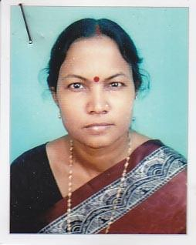 | DR. MOLINA RANI KUNDU  F/Name: Subal Chandra Kundu  M/Name:  BM & DC Reg. No:  NID:  Cell:  Address: Comilla Medical College Hospital Comilla  Blood Group:
53 | Voter No  LM-1200051  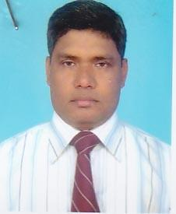 | DR. MD. GOLAM MUSTAFA  F/Name: Late Abdul Gofur  M/Name:  BM & DC Reg. No:  NID:  Cell:  Address: Lecturer Com-Med. Comilla Medical College Comilla  Blood Group:
54 | Voter No  LM-1200052  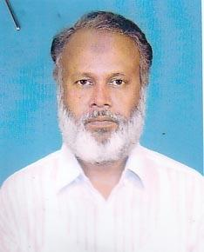 | DR. MUHAMMOD MUJIBUR RAHMAN  F/Name: Rafique Uddin Ahmed  M/Name:  BM & DC Reg. No:  NID:  Cell:  Address: Janani, 2nd Floor Near Kaliajuri Dhargha Comilla  Blood Group:
55 | Voter No  LM-1200053 | DR. ATIQUL ISLAM  F/Name: A.b. Mokbul Ahmed  M/Name:  BM & DC Reg. No:  NID:  Cell:  Address: Badar Monzil South Thakurpara Comilla  Blood Group:
56 | Voter No  LM-1200054  No Image | DR. SYED ZULFIQAR HAIDER  F/Name:  M/Name:  BM & DC Reg. No:  NID:  Cell:  Address: House-2, Block-P, Section-2 H/S Comilla  Blood Group:
57 | Voter No  LM-1200055  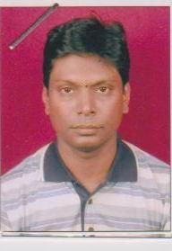 | DR. MD. NAZMUL HASAN AKHAND  F/Name: A.t.m. Aqel Akhand  M/Name:  BM & DC Reg. No:  NID:  Cell:  Address: C.D. Path. Badurtala Comilla  Blood Group:
58 | Voter No  LM-1200056 | DR. MD. SHAHAB UDDIN  F/Name: Late Md. Kurban Ali  M/Name:  BM & DC Reg. No:  NID:  Cell:  Address: Asstt. Prof. Medicine Medical College Hospital Comilla  Blood Group:
59 | Voter No  LM-1200057  No Image | DR. SHAILENDRA KUMAR MITRA  F/Name: Late Kalihar Mitra  M/Name:  BM & DC Reg. No:  NID:  Cell:  Address: TH & FPO Thana Health Complex Laksham Comilla  Blood Group:
60 | Voter No  LM-1200058  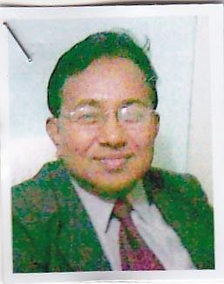 | DR. HARUN OR-RASHID  F/Name: Matiur Rahman Bhuiyan  M/Name:  BM & DC Reg. No:  NID:  Cell:  Address: EMO, General Hospital Comilla  Blood Group:
61 | Voter No  LM-1200059 | DR. TRIPTISH CHANDRA GHOSE  F/Name: Late Khitish Chandra Ghose  M/Name:  BM & DC Reg. No:  NID:  Cell:  Address: CD Path Badurtala, Comilla.  Blood Group:
62 | Voter No  LM-1200060  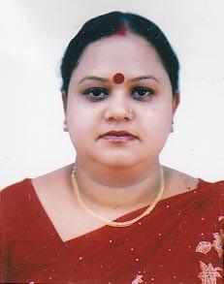 | DR. MALLIKA BISWAS  F/Name: Dharani Kanta Biswas  M/Name:  BM & DC Reg. No:  NID:  Cell:  Address: CD Path Badurtala Comilla  Blood Group:
63 | Voter No  LM-1200061 | DR. MD. ABDUL HOQUE  F/Name: Alhaj Elahi Box  M/Name: Rabeya Khatun  BM & DC Reg. No: 20542  NID: 7326905861  Cell: 01711-798081  Address: House: 352/7, Madina Mosjid Road , Thakorpara, Kotwali Model, Cumilla Sadar-3500, Cumilla  Blood Group: B+
64 | Voter No  LM-1200062 | DR. M.M. NURUS SHAFI  F/Name: Late Siddiqur Rahman  M/Name:  BM & DC Reg. No:  NID:  Cell:  Address: House-8, Block-Q Section-4, H/S Comilla  Blood Group:
65 | Voter No  LM-1200063  No Image | DR. JOGESH CHANDRA ROY  F/Name: Late Tagar Mohan Roy  M/Name:  BM & DC Reg. No:  NID:  Cell:  Address: Laksham Comilla  Blood Group:
66 | Voter No  LM-1200064  No Image | DR. MD. ENAYET HOSSAIN  F/Name: Abdul Hoque  M/Name:  BM & DC Reg. No:  NID:  Cell:  Address: Baitul Aman Station Road, Comilla  Blood Group:  E X P I R E D
67 | Voter No  LM-1200065  No Image | DR. ZOBAIDA HANNAN  F/Name: Late Mahfuzul Hoque  M/Name:  BM & DC Reg. No:  NID:  Cell:  Address: Badurtala Comilla  Blood Group:  E X P I R E D
68 | Voter No  LM-1200066  No Image | DR. MAHMUDA BEGUM  F/Name:  M/Name:  BM & DC Reg. No:  NID:  Cell:  Address: Comilla Medical Centre Laksham Road Comilla  Blood Group:
69 | Voter No  LM-1200067  No Image | DR. MD. ABUL BASHAR  F/Name:  M/Name:  BM & DC Reg. No:  NID:  Cell:  Address: Comilla Medical Centre Laksham Road Comilla  Blood Group:
70 | Voter No  LM-1200068  No Image | DR. MD. MOZAMMEL HOQUE  F/Name:  M/Name:  BM & DC Reg. No:  NID:  Cell:  Address: Comilla  Blood Group:  E X P I R E D
71 | Voter No  LM-1200069  No Image | DR. MD. KHURSHED ALAM  F/Name:  M/Name:  BM & DC Reg. No:  NID:  Cell:  Address:  Blood Group:  TRANSFERED to BMA Dhaka City  LM-1405543
72 | Voter No  LM-1200069  No Image | DR. MD. KHURSHED ALAM  F/Name:  M/Name:  BM & DC Reg. No:  NID:  Cell:  Address: Flat-6/C, 319, Elephant Road, Dhaka-1215  Blood Group:  TRANSFERED to BMA Dhaka City  LM-1405543
73 | Voter No  LM-1200070  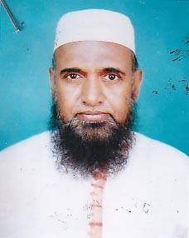 | DR. MD. SHAFIQUL HAIDER CHOWDHURY  F/Name: Md. Muzaffar Ahmed  M/Name:  BM & DC Reg. No:  NID:  Cell:  Address: Shahpara Ranir Bazar Comilla  Blood Group:
74 | Voter No  LM-1200071  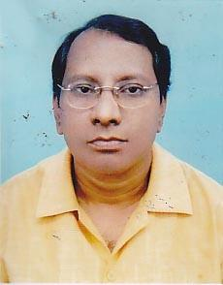 | DR. MD. ATAUR RAHMAN  F/Name: Late Md. Siddiqur Rahman  M/Name:  BM & DC Reg. No:  NID:  Cell:  Address: Diabetic Hospital Bagichagan Comilla  Blood Group:
75 | Voter No  LM-1200072  No Image | DR. MAHBUB MUTANABBI  F/Name: Bazlur Rahman Majumder  M/Name:  BM & DC Reg. No:  NID:  Cell:  Address: Consultant C.H. Sadar Hospital Feni  Blood Group:
76 | Voter No  LM-1200073  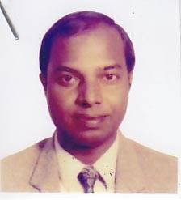 | DR. A.H. MD. GHULAM ANWAR KHAN  F/Name: Late Faizul Islam Khan  M/Name:  BM & DC Reg. No:  NID:  Cell:  Address: North Chartha Womens College Road Comilla  Blood Group:
77 | Voter No  LM-1200074  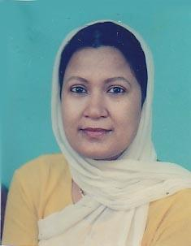 | DR. NAZMA AKHTER  F/Name: Md. Abdul Haque  M/Name:  BM & DC Reg. No:  NID:  Cell:  Address: Laksam Road Comilla  Blood Group:
78 | Voter No  LM-1200075  No Image | DR. ABDUL QUDDUS AKHAND  F/Name: Late Abdul Mazid Akhand  M/Name:  BM & DC Reg. No:  NID:  Cell:  Address: Race Cource Comilla  Blood Group:
79 | Voter No  LM-1200076  No Image | DR. FARID UDDIN AHMED  F/Name:  M/Name:  BM & DC Reg. No:  NID:  Cell:  Address: Asstt. Prof. Paed Chittagong Medical College Chittagong  Blood Group:
80 | Voter No  LM-1200077  No Image | DR. MOHAMMAD ABDUL MOBIN  F/Name: Abdul Aziz  M/Name:  BM & DC Reg. No:  NID:  Cell:  Address: Paschim Gaon Laksham Comilla  Blood Group:
81 | Voter No  LM-1200078  No Image | DR. MOHAMMAD SAYEED HOSSAIN (NELOY)  F/Name:  M/Name:  BM & DC Reg. No:  NID:  Cell:  Address: 83/B, Hatembag road, Rayer bazar, Dhaka-1209.  Blood Group:  TRANSFERED to BMA Dhaka City  LM-1405543
82 | Voter No  LM-1200079  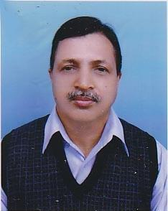 | DR. A.S.M. MOSTAQUE AHMED  F/Name: Late Sujat Ali  M/Name:  BM & DC Reg. No:  NID:  Cell:  Address: Sadar Hospital Chandpur  Blood Group:
83 | Voter No  LM-1200080  No Image | DR. NOMAN CHOWDHURY  F/Name:  M/Name:  BM & DC Reg. No:  NID:  Cell:  Address: Jawtala Comilla  Blood Group:
84 | Voter No  LM-1200081  No Image | DR. MD. JAHIRUL HOQUE  F/Name: Late Munshi Abdul Karim  M/Name:  BM & DC Reg. No:  NID:  Cell:  Address: Consultant T.B Clinic Comilla  Blood Group:
85 | Voter No  LM-1200082  No Image | DR. MD. MUSTAFIZUR RAHMAN  F/Name:  M/Name:  BM & DC Reg. No:  NID:  Cell:  Address:  Blood Group:  TRANSFERED to BMA Dhaka City  LM-1405543
86 | Voter No  LM-1200083  No Image | DR. K.B.M. ABDUR RAHMAN  F/Name:  M/Name:  BM & DC Reg. No:  NID:  Cell:  Address:  Blood Group:
87 | Voter No  LM-1200084  No Image | DR. M.A. AZIZ  F/Name:  M/Name:  BM & DC Reg. No:  NID:  Cell:  Address: Medical Officer, Chandina Health Complex,Comilla.  Blood Group:  E X P I R E D
88 | Voter No  LM-1200085  No Image | DR. M. WALIULLAH  F/Name: Late Alhaj K. Ali  M/Name:  BM & DC Reg. No:  NID:  Cell:  Address: Badurtala Comilla  Blood Group:
89 | Voter No  LM-1200086  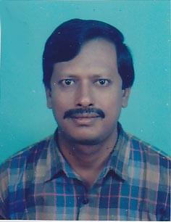 | DR. SARAL KUMER SAHA  F/Name: Nagendranath Saha  M/Name:  BM & DC Reg. No: 11448  NID:  Cell:  Address: Assistant Prof. (Anaes) Medical College Hospital, Comilla  Blood Group:
90 | Voter No  LM-1200087  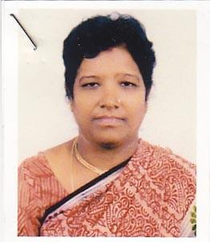 | DR. KARUNA RANI KARMAKER  F/Name: Mahendra Karmakar  M/Name:  BM & DC Reg. No:  NID:  Cell:  Address: Associate Professor (Gaynae) Comilla Medical College Comilla  Blood Group:
91 | Voter No  LM-1200087  No Image | DR. KARUNA RANI KARMAKER  F/Name: Nathendra Karmaker  M/Name:  BM & DC Reg. No:  NID:  Cell:  Address: N/A  Blood Group:
92 | Voter No  LM-1200088  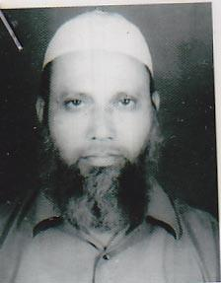 | DR. MUHAMMAD BELAL  F/Name: Late A.k.m. Hossain  M/Name:  BM & DC Reg. No:  NID:  Cell:  Address: Comilla General Hospital Comilla  Blood Group:
93 | Voter No  LM-1200089  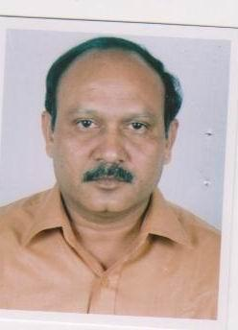 | DR. MD. BELAL HOSSAIN  F/Name:  M/Name:  BM & DC Reg. No:  NID:  Cell:  Address: Asstt. Registerer Medicine Medical College Hospital Comilla  Blood Group: B+
94 | Voter No  LM-1200090  No Image | DR. ABU MOHAMMED NURUL AHAD  F/Name: Late. Lutfe Ali  M/Name:  BM & DC Reg. No: 7865  NID:  Cell:  Address: Asstt. Prof. (Orth.) Comilla Medical College Comilla  Blood Group:
95 | Voter No  LM-1200090  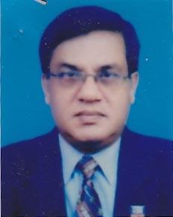 | DR. ABU MOHAMMOD NURUL AHAD  F/Name: Late Lutfe Ali  M/Name:  BM & DC Reg. No:  NID:  Cell:  Address: Asstt. Prof. (Orth.) Comilla Medical College Comilla  Blood Group:
96 | Voter No  LM-1200092  No Image | DR. MD. SHAMSUL KARIM  F/Name: Late Md. Muksud Ali  M/Name:  BM & DC Reg. No:  NID:  Cell:  Address: a  Blood Group:
97 | Voter No  LM-1200093  No Image | DR. A.H.M. MONZURUL HOQUE  F/Name: Dr. Azizur Rahman  M/Name:  BM & DC Reg. No:  NID:  Cell:  Address: Asstt. Prof. (Psych) Comilla Medical College Comilla  Blood Group:
98 | Voter No  LM-1200094  No Image | DR. FAWZIA ZAMAN SEEMA  F/Name: Dr. N. Zaman  M/Name:  BM & DC Reg. No:  NID:  Cell:  Address: C./O.-Dr. Zaman Spondhon, Rase Course Comilla  Blood Group:
99 | Voter No  LM-1200095  No Image | DR. MD. ISKANDER ZULKERNINE  F/Name: Mr. Md. Yakub  M/Name:  BM & DC Reg. No: 10114  NID:  Cell:  Address: C/O. Late Md. Eakub , Kaliazury, Comilla  Blood Group:
100 | Voter No  LM-1200096  No Image | DR. FEROZE QUADER  F/Name:  M/Name:  BM & DC Reg. No: 11380  NID:  Cell:  Address: House # 11, Road # 2A Banani, Dhaka.  Blood Group:  TRANSFERED to BMA Dhaka City  LM-1405543
101 | Voter No  LM-1200097  No Image | DR. MOHAMMAD AZIZUR RAHMAN SIDDIQUI  F/Name: Md. Anwarul Azim Siddiqui  M/Name:  BM & DC Reg. No:  NID:  Cell:  Address: Doctor's Para Badurtala Comilla  Blood Group:
102 | Voter No  LM-1200098  No Image | DR. NILUFAR PARVIN  F/Name: M.A. Samad  M/Name:  BM & DC Reg. No:  NID:  Cell:  Address: Gomoti Hospital Pvt. Ltd. Kandirpar Comilla  Blood Group:
103 | Voter No  LM-1200099  No Image | DR. NURUN NAHAR  F/Name: Dr. Abdul Latif Bhuiyan  M/Name:  BM & DC Reg. No:  NID:  Cell:  Address: Khonica South Bagichagaon Comilla  Blood Group:
104 | Voter No  LM-1200100  No Image | DR. TAHMINA BEGUM  F/Name: Zainul Abedin Mallick  M/Name:  BM & DC Reg. No:  NID:  Cell:  Address: NMC, P.O. Box-48 Comilla  Blood Group:
105 | Voter No  LM-1200101  No Image | DR. MD. HAROON OR RASHID BHUIYAN  F/Name: Rahman Bhuiyan  M/Name:  BM & DC Reg. No:  NID:  Cell:  Address: 401,Ga. Shishu Mongal Road Badurtala Comilla  Blood Group:
106 | Voter No  LM-1200102  No Image | DR. MD. MONIRUZZAMAN MILAN  F/Name: Md. Lutfur Rahman  M/Name:  BM & DC Reg. No:  NID:  Cell:  Address: Monihar South Thakurpar Rampal Road Comilla  Blood Group:
107 | Voter No  LM-1200103  No Image | DR. NURJAHAN BEGUM  F/Name: Late Md. Ali Akbar  M/Name:  BM & DC Reg. No:  NID:  Cell:  Address: Laki House Laksam Road Comilla  Blood Group:
108 | Voter No  LM-1200104  No Image | DR. A.M. ANISUR RAHMAN  F/Name: Md. Abdul Hakim  M/Name:  BM & DC Reg. No:  NID:  Cell:  Address: Munsef Bari Monohorpur Comilla  Blood Group:
109 | Voter No  LM-1200105 | DR. M.H. SHAHID SHAMIM  F/Name: Md. Abdul Latif  M/Name:  BM & DC Reg. No:  NID:  Cell:  Address: Nazrul Avenue Kandirpar Comilla  Blood Group:
110 | Voter No  LM-1200106  No Image | DR. AKTERUN NAHER  F/Name: Abdul Latif Bhuiyan  M/Name:  BM & DC Reg. No:  NID:  Cell:  Address: Protik, H-19 North Bagichagaon Comilla  Blood Group:
111 | Voter No  LM-1200107  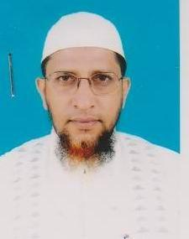 | DR. BORHANUDDIN AHMED  F/Name: Late Dr. Tayeb Ali  M/Name:  BM & DC Reg. No:  NID:  Cell:  Address: North Chartha Comilla Off MC Comilla  Blood Group:
112 | Voter No  LM-1200108 | DR. GOLAM MOHIUDDIN (DIPU)  F/Name: Late Abdul Mazid  M/Name:  BM & DC Reg. No:  NID:  Cell:  Address: South Bagichagaon Ranir Bazar Comilla  Blood Group:
113 | Voter No  LM-1200109  No Image | DR. MD. ABDUR RAHMAN  F/Name:  M/Name:  BM & DC Reg. No:  NID:  Cell:  Address: a  Blood Group:
114 | Voter No  LM-1200110  No Image | DR. K. M. ASHRAF ALI  F/Name:  M/Name:  BM & DC Reg. No:  NID:  Cell:  Address: North Chashara  Narayangonj  Blood Group:  TRANSFERED to BMA Dhaka City  LM-1405543
115 | Voter No  LM-1200111  No Image | DR. MD. ABDUL AWAL MIA  F/Name: Md. Abdul Latif  M/Name:  BM & DC Reg. No:  NID:  Cell:  Address: Asst. Prof., Eye Dept Comilla Medical College Comilla.  Blood Group:
116 | Voter No  LM-1200112  No Image | DR. MD. NAZIBUR RAHMAN KHANDAKER  F/Name: Abdul Latif Khandaker  M/Name:  BM & DC Reg. No: 11195  NID:  Cell:  Address: Asstt. Professor (Cardiology) Comilla Medical College Comilla  Blood Group:
117 | Voter No  LM-1200113  No Image | DR. A.H.M. DELWAR  F/Name: Md. Abdul Hamid  M/Name:  BM & DC Reg. No:  NID:  Cell:  Address: Flat # 116/194 Kandirpar-2, Comilla.  Blood Group:
118 | Voter No  LM-1200114  No Image | DR. MS. TAHAMINA PARVIN  F/Name: Md. Ali Azam Sikder  M/Name:  BM & DC Reg. No:  NID:  Cell:  Address: 401/Ga, Shisu Mongal Road Badurtala Comilla  Blood Group:
119 | Voter No  LM-1200115  No Image | DR. MD. SERAJUL HOQUE  F/Name: Yousuf Ali  M/Name:  BM & DC Reg. No:  NID:  Cell:  Address: Associate Prof. Surgery Comilla MC Comilla.  Blood Group:
120 | Voter No  LM-1200116  No Image | DR. A.K.M. MEHEDI HASAN  F/Name:  M/Name:  BM & DC Reg. No:  NID:  Cell:  Address: House # 68, 3/B, Road # 27,  Gulshan-01, Dhaka.  T.F. Comilla, LM-116  Blood Group:  TRANSFERED to BMA Dhaka City  LM-1405543
121 | Voter No  LM-1200117  No Image | DR. MAHBUB ALAM  F/Name: Abbas Ali  M/Name:  BM & DC Reg. No:  NID:  Cell:  Address: Dewan Lodge Yousuf School Road Comilla  Blood Group:
122 | Voter No  LM-1200118  No Image | DR. ABDUL JALIL CHOWDHURY  F/Name: Late Abdul Hamid Chowdhury  M/Name:  BM & DC Reg. No:  NID:  Cell:  Address: Chowdhury Bhaban East Bank Of Nanuar Dighi Comilla  Blood Group:
123 | Voter No  LM-1200119  No Image | DR. A.F. MUHAMMAD ULLAH  F/Name: Late Mvi. Abdul Mannan  M/Name:  BM & DC Reg. No:  NID:  Cell:  Address: Chairman, Modern Hospital Comilla  Blood Group:
124 | Voter No  LM-1200120  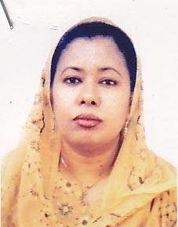 | DR. DILRUBA AKTER  F/Name: Md. Mizanur Rahman  M/Name:  BM & DC Reg. No: 24004  NID:  Cell:  Address: Talpukur North Par Comilla  Blood Group: n_a
125 | Voter No  LM-1200121 | DR. MD. MUJIBUR RAHMAN SIDDIQUI  F/Name: Md. Anwarul Azim Siddiqui  M/Name:  BM & DC Reg. No: 26664  NID:  Cell: 01716428418  Address: Yeasin Monjil 17/Kha 2nd Kandirpar Comilla  Blood Group:
126 | Voter No  LM-1200122  No Image | SYED ASHRAF HOSSAIN  F/Name: Syed Mosharraf Hossain  M/Name:  BM & DC Reg. No: 19286  NID:  Cell: 01715377599  Address: Medical Officer FPAB Comilla Branch Maternity Road Badurtola, Comilla - 3500  Blood Group:
127 | Voter No  LM-1200123  No Image | DR. MD. FAZLUR RAHMAN MAZUMDER  F/Name: Md. Julfe Ali Mazumder  M/Name:  BM & DC Reg. No: 12744  NID:  Cell: 01711342627  Address: Mo Civil Surgeon Office Comilla  Blood Group:
128 | Voter No  LM-1200124  No Image | DR. MD. HUMAYUN KABIR  F/Name: Late Khalilur Rahman Patwary  M/Name:  BM & DC Reg. No: 14630  NID:  Cell:  Address: 609, Jamjam RA Thakur Para Comilla  Blood Group:
129 | Voter No  LM-1200125  No Image | DR. MD. NAZRUL ISLAM  F/Name: Late Abdu Miah  M/Name:  BM & DC Reg. No: 26513  NID:  Cell:  Address: Delta General Hospital, Racecourse Comilla  Blood Group:
130 | Voter No  LM-1200126  No Image | DR. MD. KHURSHID ALAM  F/Name: Md. Adbul Bari  M/Name:  BM & DC Reg. No: 22484  NID:  Cell:  Address: Lecturer Department of Pathology Comilla Medical College  Blood Group:
131 | Voter No  LM-1200127  No Image | DR. MD. MAHABUBUL ISLAM MAZUMDER  F/Name: Mamtaz Uddin Mazumder  M/Name:  BM & DC Reg. No: 12784  NID:  Cell:  Address: Asstt. Prof Medicine Comilla Medical College  Blood Group:
132 | Voter No  LM-1200128  No Image | DR. MD. NAZMUL HASSAN CHOWDHURY  F/Name: Late Mominul Islam Chowdhury  M/Name:  BM & DC Reg. No: 22771  NID:  Cell: 07111310494  Address: Wali Bhaban - 2, Munsef Quarter, Comilla  Blood Group:
133 | Voter No  LM-1200129  No Image | DR. MD. ABDUL BASHAR  F/Name: Md. Abdu Samad  M/Name:  BM & DC Reg. No: 14786  NID:  Cell:  Address: Comilla Medical College Hospital Comilla  Blood Group:
134 | Voter No  LM-1200130  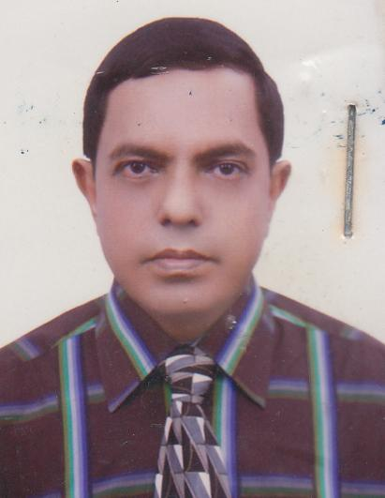 | DR. MD ABDUL LATIF  F/Name: Md. Abdus Sobhan  M/Name:  BM & DC Reg. No: 12992  NID:  Cell:  Address: Sakina Bhaban 1098 Rececourse Comilla  Blood Group:
135 | Voter No  LM-1200131  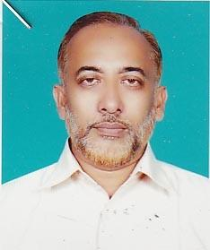 | DR. MD. ABUL KALAM AZAD  F/Name: Shamsul Haque  M/Name:  BM & DC Reg. No: 11483  NID:  Cell: 01711825053  Address: Comilla Popular Hospital Laksampur Road Comilla  Blood Group:
136 | Voter No  LM-1200132  No Image | DR. MD. ABDUS SAMAD  F/Name: Late Moslehuddin Ahmed  M/Name:  BM & DC Reg. No: 12871  NID:  Cell: 01714200835  Address: Asst Professor Biochemistry Comilla Medical College  Blood Group:
137 | Voter No  LM-1200133  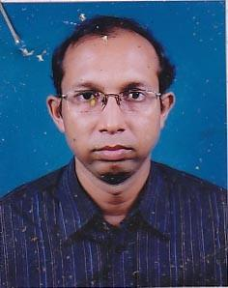 | MD. TAIFUR RAHMAN  F/Name: Md. Bazlur Rahman  M/Name:  BM & DC Reg. No: 27490  NID:  Cell: 0189116248  Address: Moon Hospital Comilla  Blood Group:
138 | Voter No  LM-1200134  No Image | DR. SHIRIN SULTANA  F/Name: Mostafa Kamal Chowdhury  M/Name:  BM & DC Reg. No: 28784  NID:  Cell:  Address: Lec. Biochemistry CMC  Blood Group:
139 | Voter No  LM-1200135 | DR. MAHBUBUL ISLAM  F/Name: Ansaruddin Khan  M/Name:  BM & DC Reg. No: 11387  NID:  Cell:  Address: Chest Diseases Clinic Badurtola Comilla  Blood Group:
140 | Voter No  LM-1200136  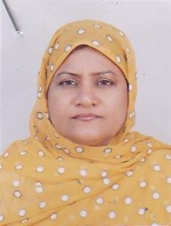 | DR. AFZALUNNESSA CHOWDHURY  F/Name: A.k. Mohammad Ali Chowdhury  M/Name:  BM & DC Reg. No: 13952  NID:  Cell:  Address: CD Hospital Shishumongal Road Badurtola Comilla  Blood Group:
141 | Voter No  LM-1200137  No Image | DR. MD. BASHIR  F/Name: Late Nayeb Ali  M/Name:  BM & DC Reg. No: 17325  NID:  Cell:  Address: General Hospital Comilla  Blood Group:
142 | Voter No  LM-1200138  No Image | DR. GOLAM SHAH JAHAN  F/Name: Late Haji Md. Aminullah  M/Name:  BM & DC Reg. No: 14970  NID:  Cell:  Address: Mamtaz Villa 351, Thakurpara Comilla  Blood Group:
143 | Voter No  LM-1200139  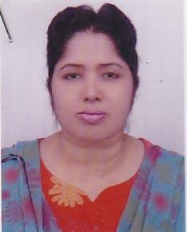 | DR. KAMRUN NAHAR  F/Name: Hazi Md. Zoynal Abedin  M/Name:  BM & DC Reg. No: 24044  NID:  Cell:  Address: Simantey House No - 166/194 Khandirpar - 2, Comilla  Blood Group:
144 | Voter No  LM-1200140  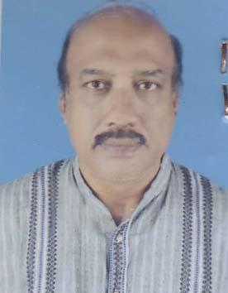 | DR. mD. aBDUL MANNAN  F/Name: Md. Anwar Hossan  M/Name:  BM & DC Reg. No: 8844  NID:  Cell: 01711749084  Address: 251 Kha New Chawdhury Para Comilla  Blood Group:
145 | Voter No  LM-1200141  No Image | DR. FARZANA ISLAM mAJUMDER  F/Name: Late Abdul Hakim Majumder  M/Name:  BM & DC Reg. No: 32308  NID:  Cell: 0189118511  Address: Thakurpara Baganbari Comilla  Blood Group:
146 | Voter No  LM-1200142  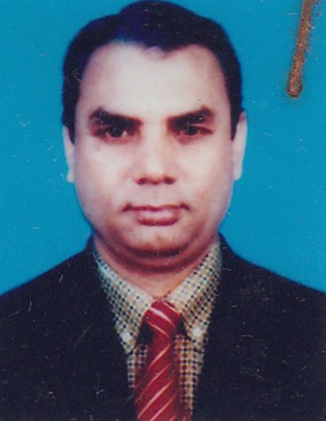 | DR. M. A. SATTAR  F/Name: Late Md. Salim Uddin  M/Name: Late Mrs. Abeda Khatun  BM & DC Reg. No: 18683  NID: 1926708056091  Cell:  Address: 609/Gha Malancha JamJam R/A Thakurpara Comilla  Blood Group: A+
147 | Voter No  LM-1200143  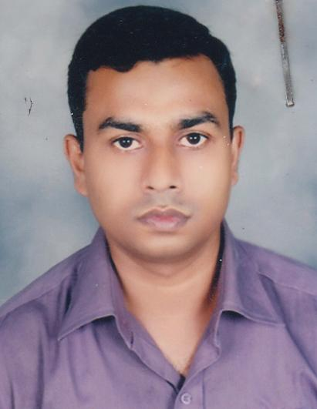 | DR. NASIR UDDIN MAHMUD  F/Name: Late Md. Shafi Ullah Mia  M/Name: Mrs. Rawshan Akter  BM & DC Reg. No: 36407  NID: 2697557397465  Cell: 01818579347  Address: Shantipur Nibash, Holding No. 87 Mrinalini Datta House Road, 3rd Ward 2nd Kandirpur Comilla  Blood Group: O+
148 | Voter No  LM-1200144  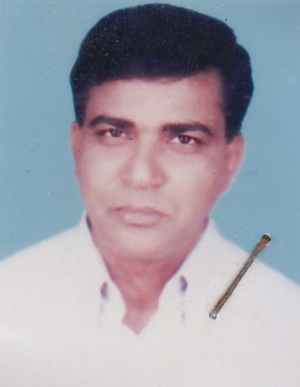 | dR. UTPAL KUMAR ROY  F/Name: Late Gopal Chandra Roy  M/Name: Bina Pani  BM & DC Reg. No: 15219  NID: 1926710067200  Cell: 01711405061  Address: 421/1 Badurtola Comilla  Blood Group: O+
149 | Voter No  LM-1200145  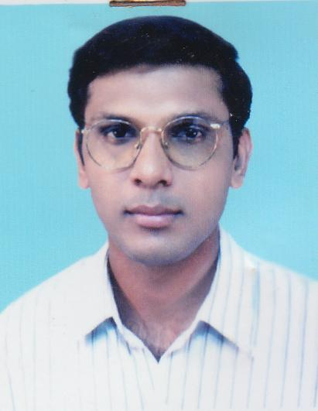 | DR. MORSHEDUL ALAM  F/Name: Late Dr. M. A. Awal  M/Name: Mrs. Samsun Nahar Begum  BM & DC Reg. No: 28938  NID: 1926712085379  Cell: 01715119515  Address: Awal Manzil, Navva Deshi East Comilla  Blood Group: A+
150 | Voter No  LM-1200146  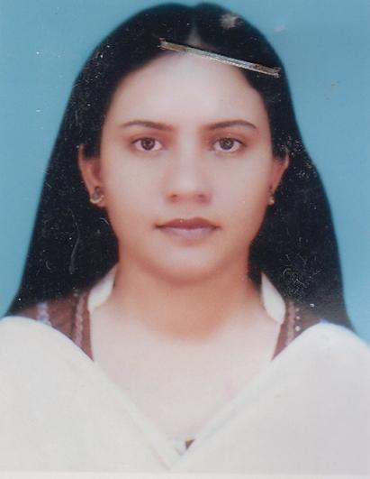 | DR. MALEKA PARVIN  F/Name: Late M. A. Malek  M/Name: Laila Parvin  BM & DC Reg. No: 29337  NID: 1926712085378  Cell: 01726336067  Address: Awal Monzil, Nanua Dighi East Comilla  Blood Group: O+
151 | Voter No  LM-1200147 | DR. MOHAMMAD HABIBUR RAHMAN PALASH  F/Name: Mohammad Faizullah  M/Name: Mrs. Mariam Begum  BM & DC Reg. No: 41564  NID: 1926710071906  Cell: 01711356945  Address: AQIB Mansion, 274/A, Jhawtala, Comilla - 3500  Blood Group: B+
152 | Voter No  LM-1200148  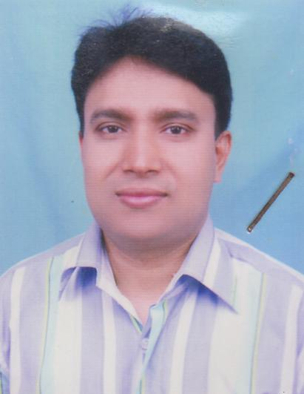 | DR. MOHAMMAD JASHIM UDDIN  F/Name: Alhaj Karam Ali  M/Name: Roymaner Nessa  BM & DC Reg. No: 32516  NID: 1916751225129  Cell: 01717227398  Address: Moon Hospital, Jhawtola Comilla  Blood Group: B-
153 | Voter No  LM-1200149  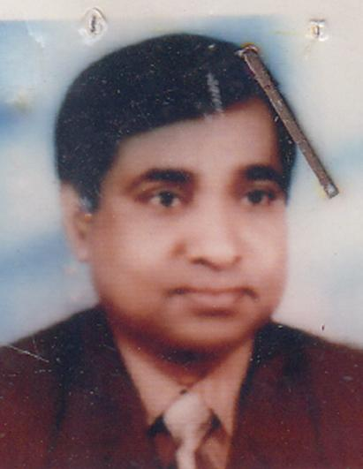 | dR. MD. ATOWER RAHMAN  F/Name: Late Alhaj Yead Ali  M/Name: Mrs. Asia Khatun  BM & DC Reg. No: 17274  NID: 1926711074945  Cell: 01711797418  Address: Consultant, Anaesthesia General Hospital, Comilla  Blood Group: A+
154 | Voter No  LM-1200150  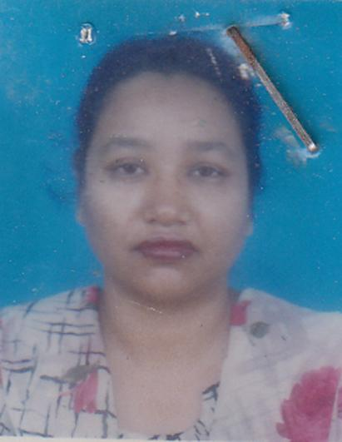 | DR. SAJEDA KHATUN  F/Name: Late A. B. M. Nesab Uddin Akhand  M/Name: Late Hena Akhand  BM & DC Reg. No: 17918  NID: 1926711074946  Cell: 01711171456  Address: Medical Officer, Bangladesh Survey Institute, Rammala Road, Comilla  Blood Group: B+
155 | Voter No  LM-1200151  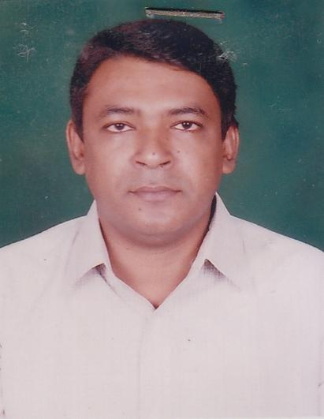 | dR. MD. mUHAIMINUR RAHMAN  F/Name: Late Md. Bazlur Rahman M.A. LL.B Advocate  M/Name: Mrs. Ayesha Shamsun Nessa  BM & DC Reg. No: 44714  NID: 1926705029677  Cell: 01715184662  Address: 86, Gangchar, Thana Road, Comilla  Blood Group: A+
156 | Voter No  LM-1200152  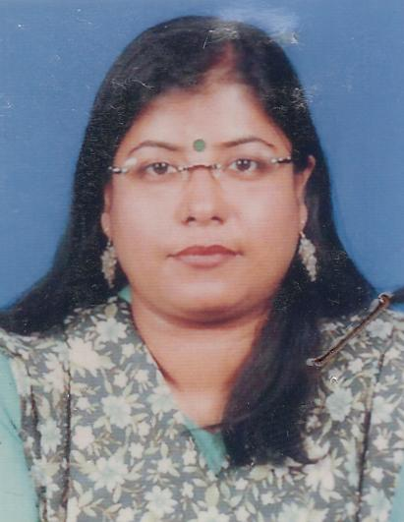 | dR. S. M. KHUSBUL jANNAT  F/Name: Dr. Md. Khorsheduzzaman  M/Name: Rabeya Khorshed  BM & DC Reg. No: 40093  NID: 2694261653163  Cell: 01715593160  Address: West Dharmasagor Par, Jhaotola Momotamoi, Comilla  Blood Group: O+
157 | Voter No  LM-1200153  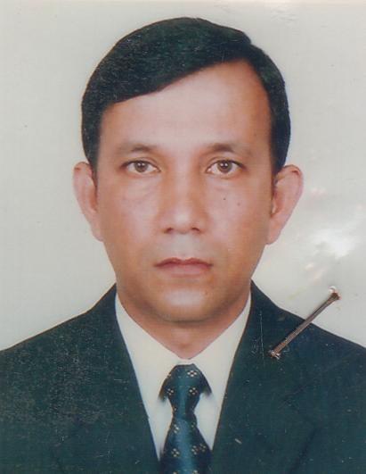 | DR. MD. REZAUL KARIM  F/Name: A. F. Md. Khurshed  M/Name: Mohsena Akter  BM & DC Reg. No: 31829  NID: 19267170070652  Cell: 01712525287  Address: West Dharmasagor Par, Jhaotola, Momotamoi, Comilla  Blood Group: B+
158 | Voter No  LM-1200154  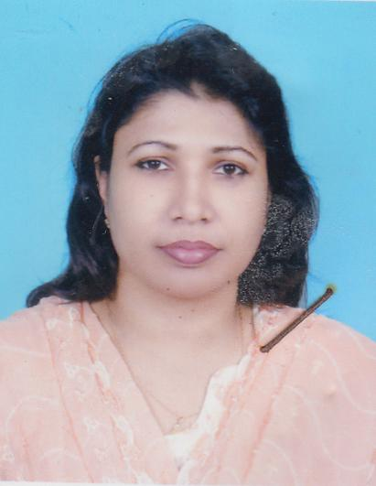 | DR. SARTAJ BEGUM  F/Name: Md. Mafiz Uddin  M/Name: Mrs. Rahima Khatun  BM & DC Reg. No: 22555  NID: 0126710071801  Cell: 01712015696  Address: 333, Jhawtola (Main road) Comilla  Blood Group: B+
159 | Voter No  LM-1200155 | DR. MD. ZAHIRUL HAQUE  F/Name: Late Md. Muksud Ali  M/Name: Late Mrs. Afia Khatun  BM & DC Reg. No: 19796  NID: 0126710071953  Cell: 01711102872  Address: 333, Jhawtala (1st Floor), Comilla  Blood Group: A-
160 | Voter No  LM-1200156  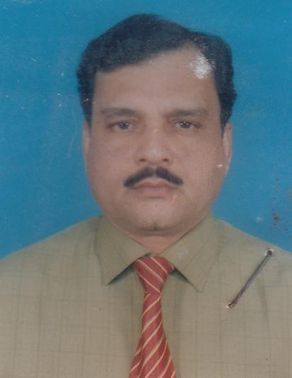 | DR. m. AKHTAR HOSSAIN  F/Name: Late Akbor Ali Mollah  M/Name: Late Amina Begum  BM & DC Reg. No: 15444  NID: 1926714098317  Cell: 01711964076  Address: 30/20 \'Ka\' South chartha, Comilla (Present Place of Posting. General Hospital, Comilla)  Blood Group: A+
161 | Voter No  LM-1200157  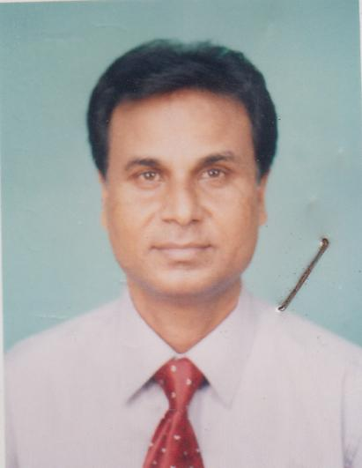 | DR. sADHAN CHANDRA PAUL  F/Name: Nitai Chandra Paul  M/Name: Late Usha Rani Paul  BM & DC Reg. No: 13600  NID: 1926708055016  Cell: 01712133349  Address: Thikana Apartment (4 - A), Rammala Road, Thakurpara (South), Comilla  Blood Group: B+
162 | Voter No  LM-1200158  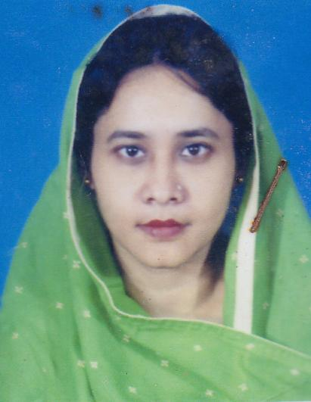 | DR. FATEMA RAHMAN  F/Name: Md. Habibur Rahman Bhuiyan  M/Name: Sharifunnesa  BM & DC Reg. No: 22466  NID: 1926710068007  Cell: 01711336673  Address: Kingshuk & Pipul, 693/Ka, Jhawtala Comilla  Blood Group: A+
163 | Voter No  LM-1200159  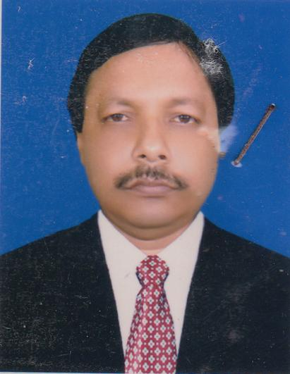 | DR. MD. MUJIBUR RAHMAN  F/Name: Late Md. Monirul Islam  M/Name: Late Saleha Begum  BM & DC Reg. No: 18304  NID: 1926710067026  Cell: 01712078619  Address: \'Farlodge\' 5/1/GA, Nazrul Avenue Kandirpar, Comilla  Blood Group: B+
164 | Voter No  LM-1200160  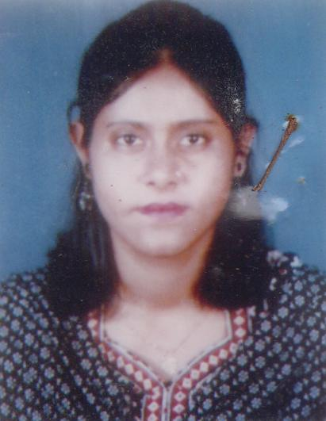 | DR. PARVEEN AKTER  F/Name: Late Abdul Kashem  M/Name: Mofreda Begum  BM & DC Reg. No: 28950  NID: 1926710066984  Cell: 01715290323  Address: \'Farlodge\' 511/Ga, Nazrul Avenue, Kandirpar, Comilla  Blood Group: B+
165 | Voter No  LM-1200161  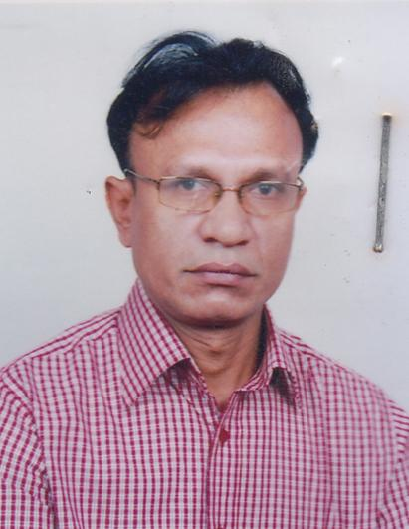 | DR. A. B. M. SHAMSUDDIN AHMED  F/Name: Late Nurul Islam  M/Name: Mrs. Ameena Begum  BM & DC Reg. No: 17333  NID: 1926710067062  Cell: 01711345758  Address: Medical Officer (CC) District Family Planning Office; Comilla  Blood Group: A+
166 | Voter No  LM-1200162  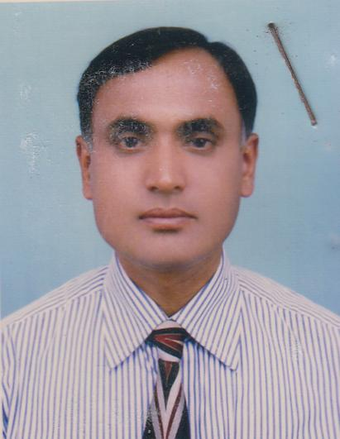 | DR. MD. HARUN AR RASHID  F/Name: Md. Siddiqur Rahman  M/Name: Mrs. Abida Khatun  BM & DC Reg. No: 20115  NID: 1916790188282  Cell: 01711140191  Address: Lecturer (Anatomy) Comilla Medical College, Comilla  Blood Group: A+
167 | Voter No  LM-1200163  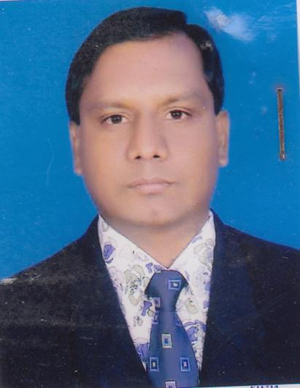 | DR. MD. ZAHIRUL ISLAM BADAL  F/Name: Md. Abdul Aziz  M/Name: Mrs. Rezia Begum  BM & DC Reg. No: 18347  NID: 1913335359929  Cell: 01819111019  Address: Asstt. Prof. , Pathology Deptt., Eastern Medical College & Hospital, Comilla  Blood Group: B+
168 | Voter No  LM-1200164  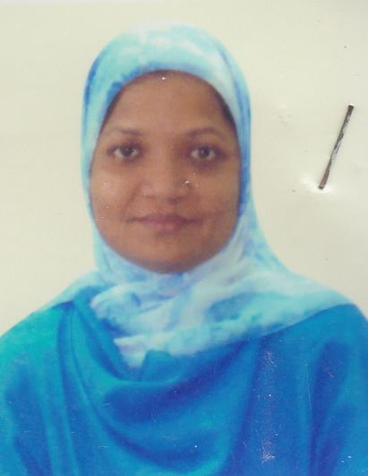 | DR. MUSAMMAT SHAMIMA AKTER  F/Name: Md. Shova Miah  M/Name: Amena Begum  BM & DC Reg. No: 26979  NID: 1913358313957  Cell: 01711909060  Address: \'Shova\' North Racecourse (Katherpool) Comilla - 3500  Blood Group: O+
169 | Voter No  LM-1200165  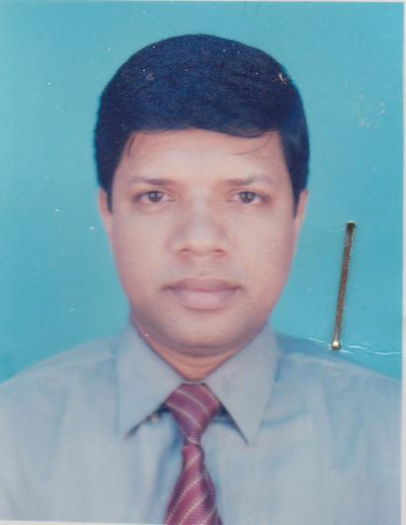 | DR. FARUK AHMED  F/Name: Md. Sirajul Huque  M/Name: Mrs. Hasina Begum  BM & DC Reg. No: 27249  NID: 2699039594004  Cell: 01711447417  Address: Asstt. Surgeon, Chauddagram Health Complex, Chauddagram, Comilla  Blood Group: O+
170 | Voter No  LM-1200166  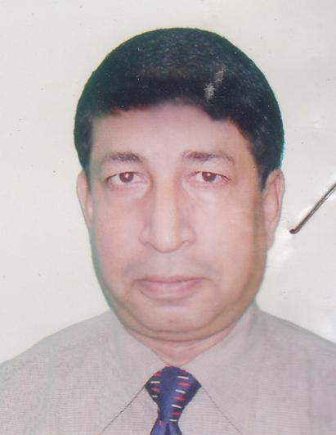 | PROFESSOR DR. MD. ENAMUL HOQUE  F/Name: Mozammel Hoque  M/Name: Begum Morium Hoque  BM & DC Reg. No: 14976  NID: 1926703011939  Cell: 01711749564  Address: Professor & Head of Radiology Dept. Comilla Medical College, Comilla  Blood Group: A+
171 | Voter No  LM-1200167  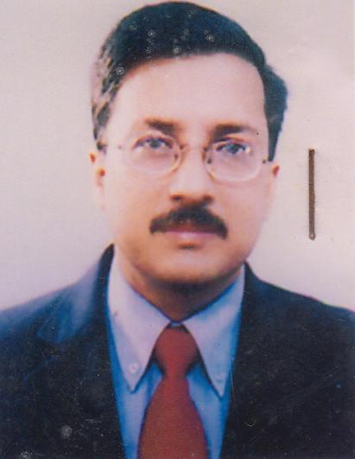 | DR. ABUL BASHAR MOHAMMAD KHURSHID ALAM  F/Name: Md. Maminul Haque  M/Name: Begum Jahanara Haque  BM & DC Reg. No: 13976  NID: 1926710068006  Cell: 01711749096  Address: Associate Professor (Surgery) Comilla Medical College, Comilla  Blood Group:
172 | Voter No  LM-1200168  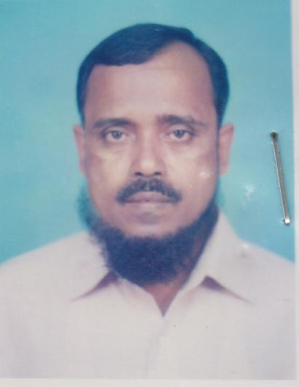 | DR. MD. RAFIQUL ISLAM SARKAR  F/Name: Late Kafiluddin Sarkar  M/Name: Late Saleha Begum  BM & DC Reg. No: 15095  NID:  Cell: 01711385898  Address: Jr. Consultant E.N.T. Comilla Medical College Hospital  Blood Group: B+
173 | Voter No  LM-1200169  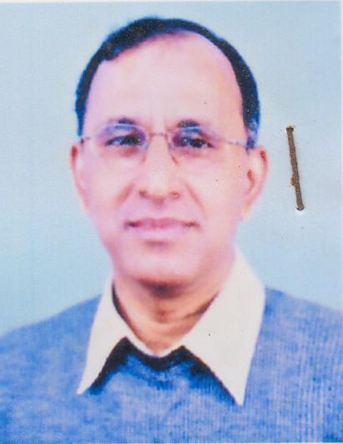 | DR. ABDUL BAKI ANIS  F/Name: Dr. Abdur Rab  M/Name: Sufia Akhter  BM & DC Reg. No: 9425  NID:  Cell: 01716075444  Address: Moon Hospital Jhawtala, Comilla  Blood Group: A+
174 | Voter No  LM-1200170  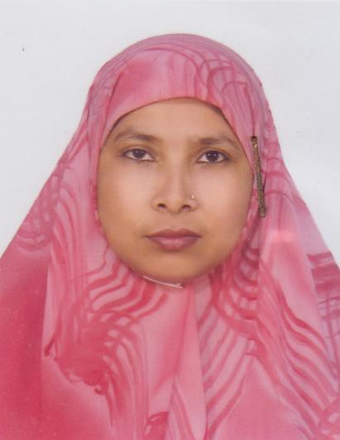 | DR. NARGIS AKTER  F/Name: Md. Abdur Razzak  M/Name: Nurannahar Begum  BM & DC Reg. No: 20157  NID: 1926708056096  Cell: 01711161637  Address: Comilla Medical College Hospital, Comilla  Blood Group: B+
175 | Voter No  LM-1200171  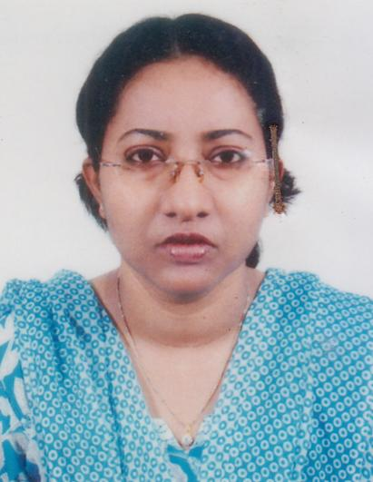 | DR. FAHMIDA YESHMINE  F/Name: Md. Hanif  M/Name: Mono ara Begum  BM & DC Reg. No: 23428  NID: 2695435089362  Cell: 01715005826  Address: Flat - 3-E, 8/1, Shantibag, Dhaka - 127 Lecturer Comilla Medical College, Comilla  Blood Group: A+
176 | Voter No  LM-1200172 | DR. mOHAMMAD IZAZUL HOQUE  F/Name: Late Tayeb Ali  M/Name: Late Rezia Khatun  BM & DC Reg. No: 23459  NID:  Cell: 01711308005  Address: Korobi, 421/1, Badurtola Comilla (2nd floor)  Blood Group: O+
177 | Voter No  LM-1200173  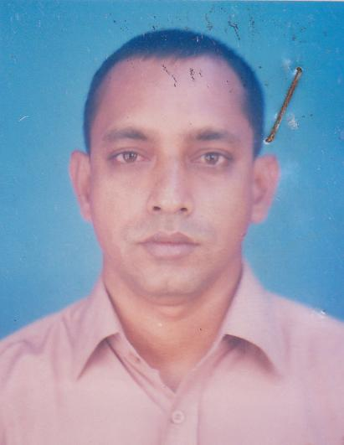 | DR. S. M. AZAM CHAUDHURY  F/Name: Late S. M. Abul Bashar Chaudhury  M/Name: Late Hanufa Khatun  BM & DC Reg. No: 24729  NID:  Cell: 01711375638  Address: C/O, Chandana Villa; 137, Gobindapur, Ramalla Road; Comilla - 3500  Blood Group: O+
178 | Voter No  LM-1200174  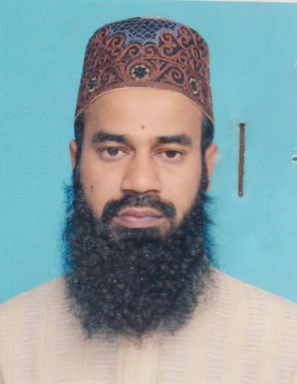 | DR. SHAH MUHAMMAD MUSTAQIM BILLAH  F/Name: Shah Aftab Uddin Ahmad  M/Name: Sayeda Nurunnahar Begum  BM & DC Reg. No: 36655  NID: 2691650128521  Cell: 01711371790  Address: Department of Radiology & Imaging Eastern Medical College, Comilla  Blood Group: A+
179 | Voter No  LM-1200175  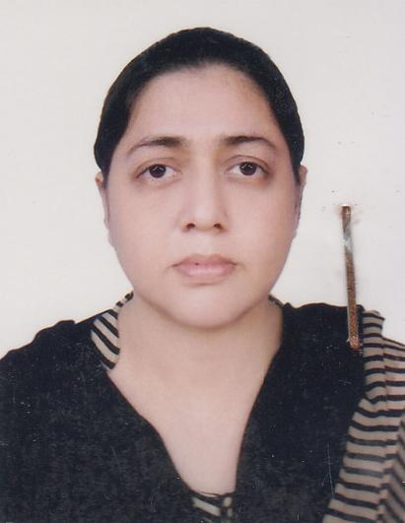 | DR. SHIRIN AKHTER  F/Name: Md. Hashem Khan  M/Name: Mrs. Dilruba Begum  BM & DC Reg. No: 26797  NID: 1926708053973  Cell: 01711162661  Address: Orchid, 609/Cha, 2nd Kandirpar (Thakur Para) M.A. Salam Rd. Zam Zam R/A Comilla  Blood Group: O-
180 | Voter No  LM-1200176 | DR. M. REZAUL KARIM  F/Name: Late M. A. Gafur  M/Name: Mrs. Rahima Khatun  BM & DC Reg. No: 22294  NID: 1926708053972  Cell: 01711796301  Address: Orchid, 609/Cha 2nd Kandirpar (Thakurpara) M.A. Salam Rd Zamzam R/A, Comilla  Blood Group: O+
181 | Voter No  LM-1200177  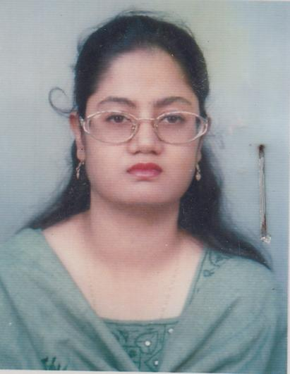 | DR. NAZNIN AKHTER JAHAN  F/Name: Late Md. Abdul Quddus Bhuiya  M/Name: Mrs. Nurjahan Begum  BM & DC Reg. No: 31627  NID: 1926712082808  Cell: 01714348248  Address: North Chartha, Taltola, Comilla  Blood Group: O+
182 | Voter No  LM-1200178  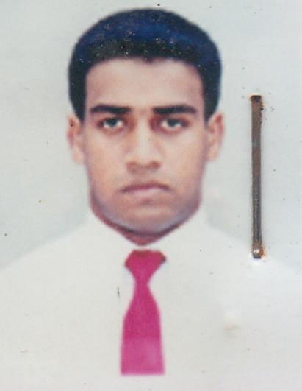 | DR. FUZAEL AHMED  F/Name: Al-haj Shamsul Haque  M/Name: Hossna Ara Begum  BM & DC Reg. No: 48527  NID: 1926705030662  Cell: 01711388278  Address: Pantho Nibash Holding No - 463 Lala Pukor East Mogutoly Comilla  Blood Group: O+
183 | Voter No  LM-1200179 | DR. mD. HABIBUR RAHMAN  F/Name: Md. Eaqub Ali  M/Name: Malaneba Begum  BM & DC Reg. No: 13165  NID: 1926708053818  Cell: 01711867843  Address: Dept of Pediatines, Come H  Blood Group: A+
184 | Voter No  LM-1200180  No Image | DR. MD. JAMAL SALEH (ARZU)  F/Name: Md. Abdul Awal  M/Name:  BM & DC Reg. No: 18418  NID:  Cell:  Address: Asst. Prof. (Shishu Mother), Comilla Medical College Hospital, Comilla.  Blood Group:
185 | Voter No  LM-1200181 | DR. MD ABDUL LATIF  F/Name: Md. Abdus Sobhan  M/Name: Afia Khatun  BM & DC Reg. No: 12992  NID:  Cell: 01712216130  Address: Sakina Bhaban, 1098 Race Course, Comilla  Blood Group:
186 | Voter No  LM-1200182 | DR. MOHAMMAD HABIBUR RAHMAN  F/Name:  M/Name:  BM & DC Reg. No: 41349  NID: 1926712083847  Cell: 01717497858  Address: Banolata, H/N - 271, North Chartha Comilla  Blood Group: A+  TRANSFERED to BMA Dhaka City  LM-1405543
187 | Voter No  LM-1200183  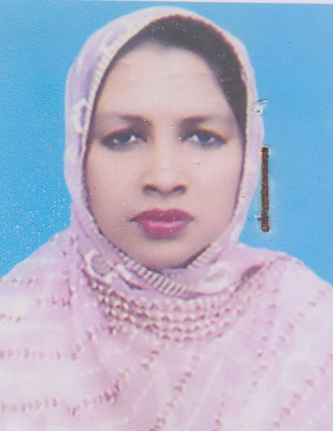 | DR. TANZINA sULTANA  F/Name: Afzalur Rahman  M/Name: Saleha Begum  BM & DC Reg. No: 19777  NID: 1329507675661  Cell: 01710818284  Address: 27/Kha Gobindopur, Tomsom Bridge (North) Comilla  Blood Group: O+
188 | Voter No  LM-1200184  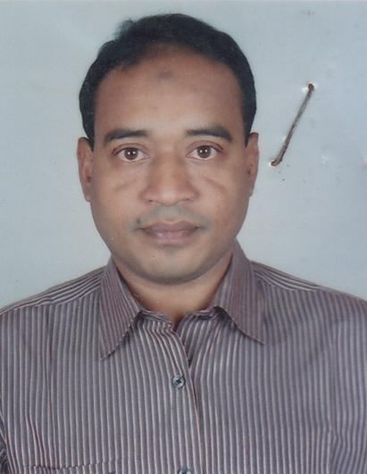 | DR. MD. HARUNUR RASHID  F/Name: Md. Nazmul Hoque  M/Name: Hosna Ara Begum  BM & DC Reg. No: 34434  NID: 1926710065603  Cell: 01715450490  Address: 790, Farid Monjil, Shaha Para Ranir Bazar, Comilla  Blood Group: O+
189 | Voter No  LM-1200185 | DR. MOHAMMAD ABDUL HANNAN  F/Name: Mohammad Abdul Malek  M/Name: Mrs. Anwara Begum  BM & DC Reg. No: 37402  NID: 2699039653750  Cell: 01711206081  Address: Comilla Hospital (pvt) Ltd. 333 Jhaotola, Comilla  Blood Group: B+
190 | Voter No  LM-1200186  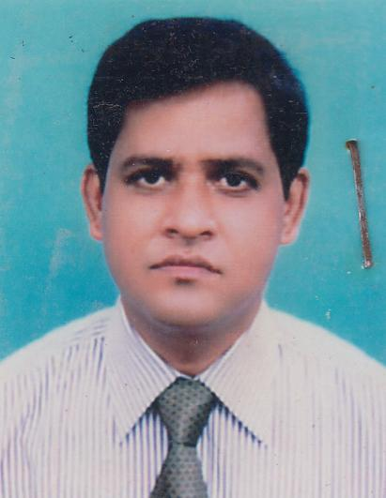 | DR. MD. SHAHJAHAN  F/Name: Md. Tayeb Ali  M/Name: Mrs. Delowara Begum  BM & DC Reg. No: 28448  NID: 1926703012002  Cell: 01711394217  Address: R.K. Lodge, 1045 East Race Course Comilla - 3500  Blood Group: B+
191 | Voter No  LM-1200187  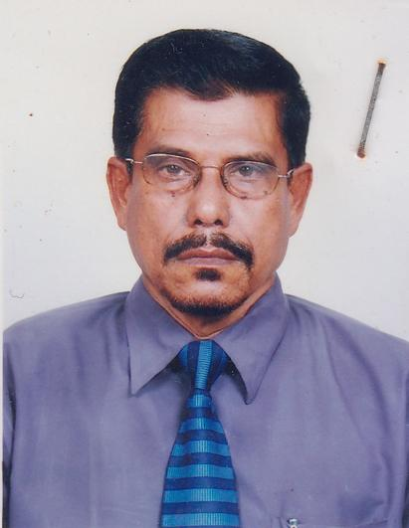 | PROF. DR. SYED JAHIRUL ISLAM  F/Name: Syed Abdul Halim  M/Name: Syeda Arjan Bibi  BM & DC Reg. No: 6196  NID:  Cell: 01711861769  Address: Principal Mainamoti Medical College, Comilla - 3500  Blood Group: B+
192 | Voter No  LM-1200188  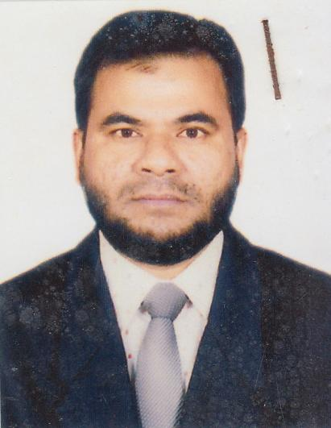 | DR. MD. DELWAR HOSSAIN  F/Name: Late Afaz Uddin  M/Name: Mrs. Shariater Nessa  BM & DC Reg. No: 23559  NID: 1926708057837  Cell: 01715707707  Address: 324 - Comilla Tower, Lailsam Road, Comilla  Blood Group: O+
193 | Voter No  LM-1200189  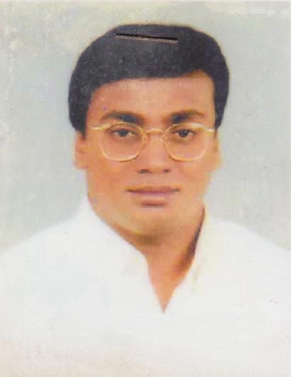 | DR. MD. AMAN ULLAH  F/Name: Dr. Abdul Hamid  M/Name: Mrs. Amena Begum  BM & DC Reg. No: 20187  NID: 2696406682085  Cell: 01817549672  Address: Medicomplex Badurtala, Comilla  Blood Group: A+
194 | Voter No  LM-1200190  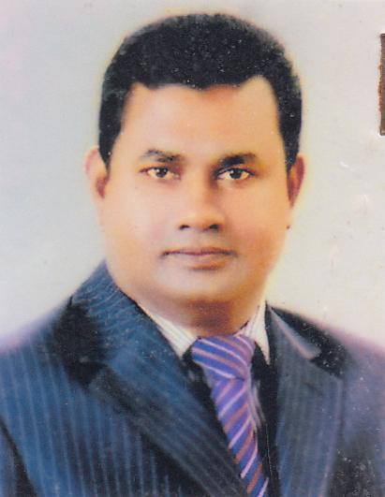 | DR. MD NUR ULLAH RAYHAN  F/Name: Late Sufi Serajal Hoque  M/Name: Late Ayesha Khatun  BM & DC Reg. No: 21644  NID: 1927201687456  Cell: 01711827300  Address: Citynova Medical Services 14 Nashratpur, Laksam, Comilla - 3570  Blood Group: O+
195 | Voter No  LM-1200191 | DR. MD. RASEL AHMED CHOWDHURY  F/Name: Md. Abdul Hannan Chowdhury  M/Name: Begum Rokeya  BM & DC Reg. No: 46953  NID: 1926712084787  Cell: 017170191714  Address: 233/215, Rokeya Maternity Clinic Degumboritola, Bazrapur, Comilla  Blood Group: B+
196 | Voter No  LM-1200192  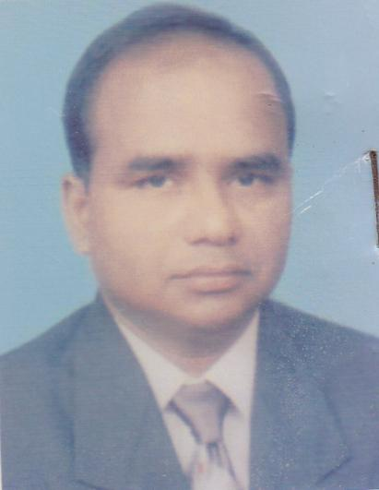 | DR. MD. AZIZUL HOSSAIN  F/Name: Md. Rafiqul Islam  M/Name: Mrs. Jahara Khatun  BM & DC Reg. No: 23605  NID: 9196201108345  Cell: 01711111299  Address: Assistant Professor Pediatric Nephrology, Comilla Medical College  Blood Group: B+
197 | Voter No  LM-1200193  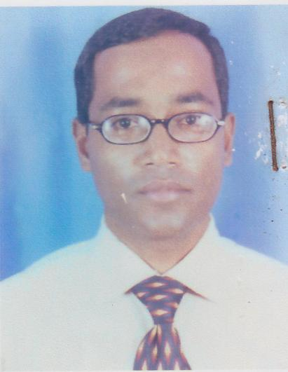 | dR. MOHAMMAD ABDULLAH AL HASAN  F/Name: Mr. Mohammad Abdus Salam  M/Name: Mrs. Rezia Begam  BM & DC Reg. No: 23380  NID: 6725802698614  Cell: 01713375261  Address: Holding No - 13/11, Chutora Colony (East Gate) Comilla - 3500  Blood Group: O+
198 | Voter No  LM-1200194 | DR. MOHAMMAD MOSTAFA KAMAL (MILON)  F/Name: Mohammad Abdul Kader  M/Name: Rahima Begum  BM & DC Reg. No: 40274  NID: 1913115456936  Cell: 01712745975  Address: Nova Medical Center, EPZ Road, Tomsom Bridge, Comilla  Blood Group: B+
199 | Voter No  LM-1200195  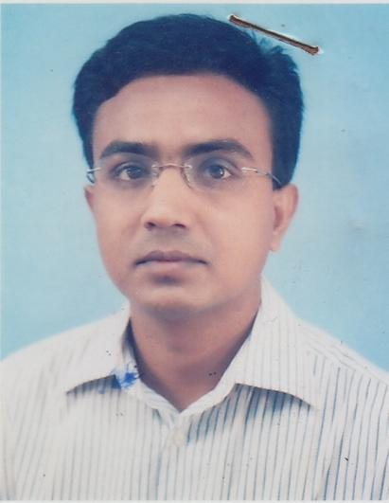 | DR. MOHAMMAD RASHED UZ ZAMAN (RASHED)  F/Name: Dr. Mohammed Faruk Uz Zaman  M/Name: Mrs. Fazila Khatun  BM & DC Reg. No: 33840  NID: 1923306302832  Cell: 01711827454  Address: House No : 1, Road No: 2, Tomson Bridge Comilla  Blood Group: B-
200 | Voter No  LM-1200196  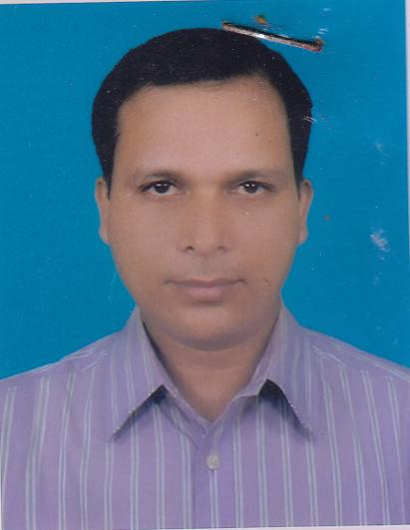 | dR. MOHAMMAD ZAHIDUR RAHMAN MAZUMDER  F/Name: Abdur Rahman Mazumder  M/Name: Suraiya Begum  BM & DC Reg. No: 35254  NID: 1916765155985  Cell: 01727533533  Address: Anesthesiologist, Comilla Medical College Hospital Comilla  Blood Group: B-
201 | Voter No  LM-1200197  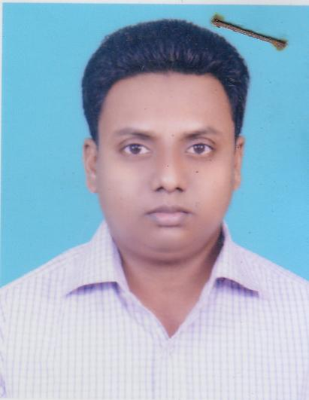 | DR. MD. SALEJAHUR  F/Name: Md. Abdus Salam  M/Name: Nure Kawsar  BM & DC Reg. No: 48114  NID: 1915415150578  Cell: 01727007373  Address: Comilla Diabetic Hospital Bagichagao Comilla  Blood Group: AB_po
202 | Voter No  LM-1200198  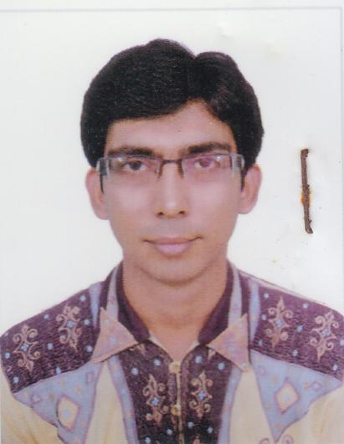 | DR. ABU TAHER MUHIT  F/Name: Md Mokhlesur Rahman  M/Name: Late Rawshan Ava  BM & DC Reg. No: 41697  NID:  Cell: 01711122162  Address: Chairman, Comilla National Hospital Sadar Hospital -1 Raod Comilla  Blood Group:
203 | Voter No  LM-1200199  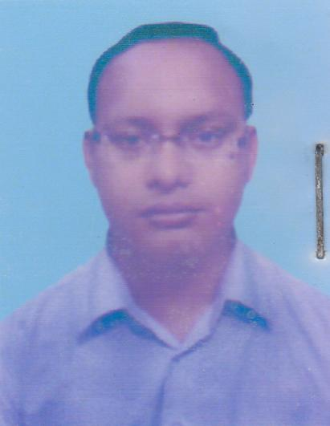 | DR. S.M. TAHIDUR RAHMAN (SUMON)  F/Name: S. M. Mosharaf Hossain  M/Name: Suriya Begum  BM & DC Reg. No: 38307  NID: 1594115239289  Cell: 01712248371  Address: Eastern Medical College, Assis Prof Anesthesiology  Blood Group: O+
204 | Voter No  LM-1200200  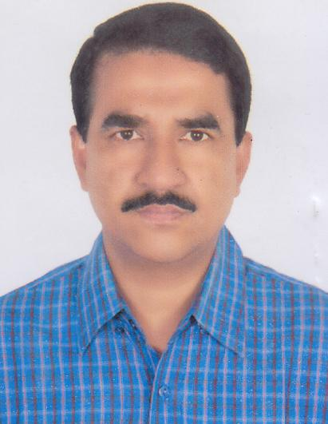 | DR. MD. JAHANGIR HOSSAIN BHUIYAN  F/Name: Md. Habibur Rahman Bhuiyan  M/Name: Late Bilkis Begum  BM & DC Reg. No: 22823  NID: 1918780895363  Cell: 01712251060  Address: Asstt. Professor, Surgery, Comilla Medical College  Blood Group: A+
205 | Voter No  LM-1200201  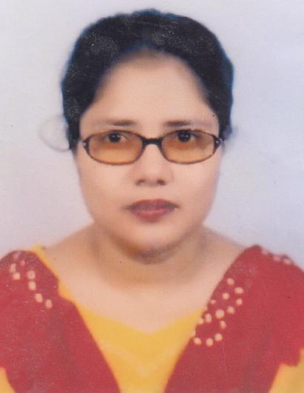 | dR. FARHANA BEGUM  F/Name: Md. Amzad Hossain  M/Name: Mrs. Fatema Begum  BM & DC Reg. No: 29795  NID: 1918780895398  Cell: 01718548567  Address: Jr. Consultant, Gynae, Upazilla Health Complex, Nangitkot, Comilla  Blood Group: O+
206 | Voter No  LM-1200202  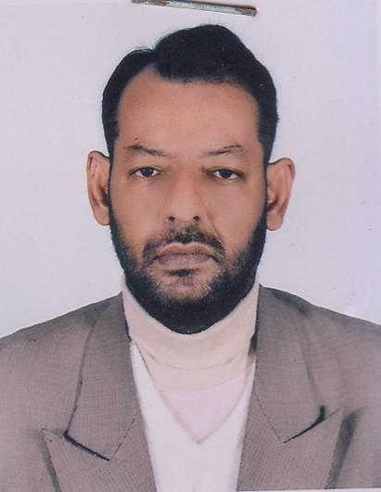 | DR. SALAHUDDIN MAHMUD  F/Name: Late. Mortuz Ali  M/Name: Mrs. Monowara Begum  BM & DC Reg. No: 24095  NID: 1926708056769  Cell: 01711188468  Address: Jeenath Mohal, 551, South Thakur Para, Comilla  Blood Group: O+
207 | Voter No  LM-1200203  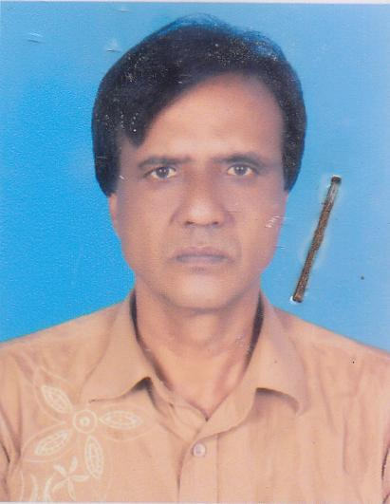 | DR. G.M.A. HANNAN  F/Name: Late Alhaj Elahi Box  M/Name: Mrs. Ayesha Khatoon  BM & DC Reg. No: 27223  NID: 1926711078102  Cell: 01716161226  Address: Holding no- 26, Munsef Bari, Comilla  Blood Group: AB+
208 | Voter No  LM-1200204  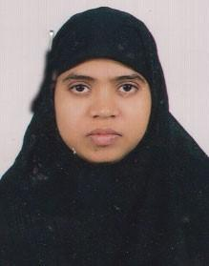 | DR. MARIAM SHEME  F/Name: Late Md. Shamsul Huda  M/Name: Late Mrs. Roushan Ara  BM & DC Reg. No: 36694  NID: 2695044872217  Cell: 01717234995  Address: Shantipur Nibas ,1st Floor, 86, Mrinalini Dalta Hoste 1 Road, 2nd Kanadirpar, Comilla  Blood Group: A+
209 | Voter No  LM-1200205  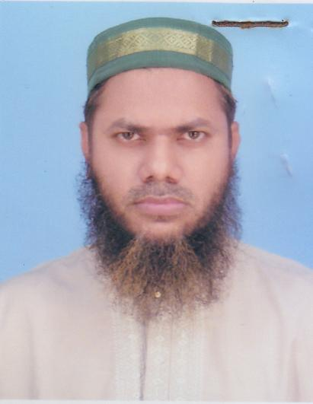 | DR. MD. DELWAR HOSSAIN  F/Name: Md. Abdul Wahab  M/Name: Fatema Begum  BM & DC Reg. No: 21356  NID: 1926710070906  Cell: 01713100731  Address: Dr. Delwar Eye care Centre ( Raice Cource Eye Hospital), 1356/1, Mahdiilh, Raice Cource, Comilla  Blood Group: B+
210 | Voter No  LM-1200206  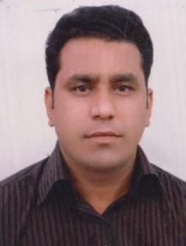 | DR. MOHAMMAD MONIRUZZAMAN  F/Name: Mohammad Moslem Uddin  M/Name: Olida Begum  BM & DC Reg. No: 46859  NID:  Cell: 0171751554  Address: Vill:Alekher Char, Po-Durgrapur, Ps-Kotwali, Comilla  Blood Group:
211 | Voter No  LM-1200207  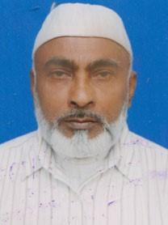 | DR. MD. ABDUL MALEQUE  F/Name: Late Dr. Asad Ali  M/Name: Late Sahera Khatoon  BM & DC Reg. No: 5363  NID: 19863670801  Cell: 01731999010  Address: Vill. Farid Pur, P.O Mainamati Bazar, P.S: Burichong, Dist: Comilla  Blood Group: n_a
212 | Voter No  LM-1200208 | DR. MAHMUD ZAMAN  F/Name: Dr. Md. Abdul Maleque  M/Name: Delowara Begum  BM & DC Reg. No: 44234  NID: 1911863670804  Cell: 01711466496  Address: Vill: Faridpur P/O : Maynamoti Bazar, P/S: Burichong, Comilla  Blood Group: A+
213 | Voter No  LM-1200209  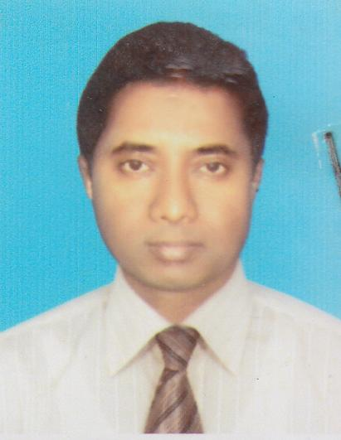 | DR. MD SHAZIBUR RASHID  F/Name: Md. Fazlur Rashid  M/Name: Aysha Khaton  BM & DC Reg. No: 30351  NID:  Cell: 01711371744  Address: Baitul Abedin, 239, Kaliajury, Comilla, UHC, Muradnagar  Blood Group: B+
214 | Voter No  LM-1200210  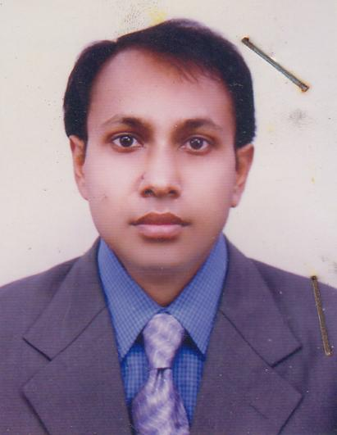 | DR. MAHMUDUL HASAN  F/Name: Md. Aminul Haq  M/Name: Mrs. Nargis Akter  BM & DC Reg. No: 37653  NID: 1926707045513  Cell: 01712166842  Address: Assist. Surgeon, Purba Dhair (West), H&FWC, Upazilla Health Complex, Muradnagar, Comilla  Blood Group: O+
215 | Voter No  LM-1200211  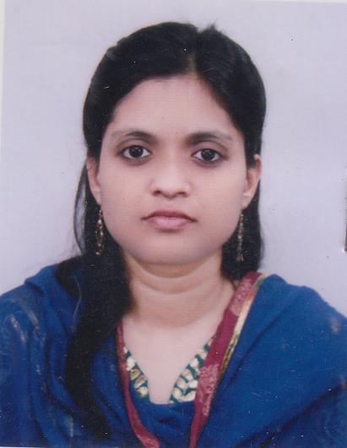 | DR. AFROZA HASHEM  F/Name: Md. Abul Hashem Bhuiyan  M/Name: Mrs. Rafiqua Hashem  BM & DC Reg. No: 46009  NID: 1926707045514  Cell: 01711447839  Address: Bristi Bilash, H/N: 27, West of New Hostel, Near mazar, Tomron Bridge, Cumilla  Blood Group: A+
216 | Voter No  LM-1200212  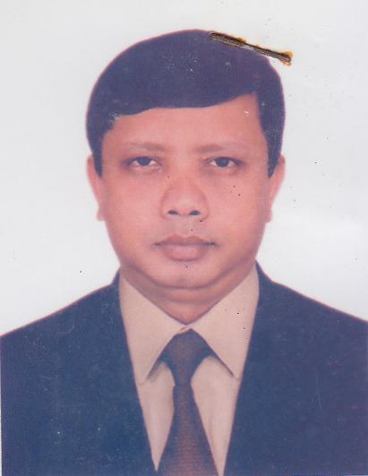 | DR> TAWFIQUN NABI KHAN  F/Name: Wahidun Nabi Khan  M/Name: Akhtar Hasina  BM & DC Reg. No: 22286  NID: 1926711076276  Cell: 01711135046  Address: Comilla Diabetic Hospital, Comilla  Blood Group: O+
217 | Voter No  LM-1200213  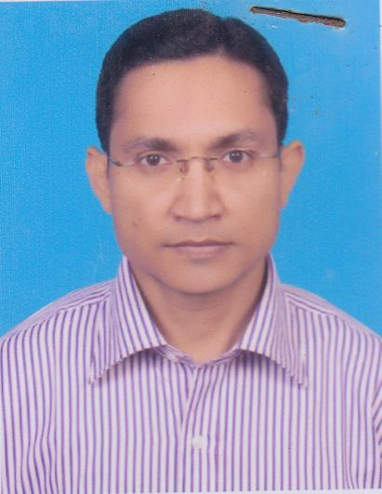 | DR. AJIT KUMAR PAUL  F/Name: Dulal Chandra Paul  M/Name: Monju Paul  BM & DC Reg. No: 28746  NID:  Cell: 01713409655  Address: Senior Consultant, Diabetic Hospital, Comilla  Blood Group: O+
218 | Voter No  LM-1200214  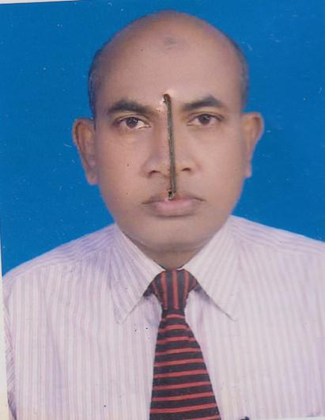 | DR. MOHAMMAD ZAKIR HOSSAIN  F/Name: Late. Md. Junab Ali  M/Name: Mrs. Anwara Begum  BM & DC Reg. No: 18632  NID: 1910982246050  Cell: 01711153217  Address: Medical Officer (MCH-FP), Upazilla Family Planning Officer, Sadar South, Comilla  Blood Group: AB+
219 | Voter No  LM-1200215 | DR. MD MUSTAFA KAMAL AZAD  F/Name: Late Abdus Salam  M/Name: Mb Takera Khatun  BM & DC Reg. No: 17589  NID:  Cell: 01715147121  Address: Salam Manjil,2nd Muradpur, Bhuianpukur Per,, Comilla.  Blood Group:
220 | Voter No  LM-1200216  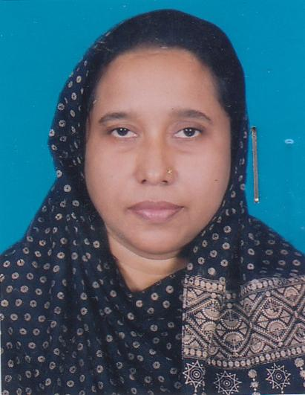 | DR. RAIHANA SULTANA BEGUM  F/Name: Late. Abdur Rahman  M/Name: Late. Saleha Khatun  BM & DC Reg. No: 17668  NID: 1926714099780  Cell: 01716932236  Address: 2nd Muradpur, Bhuiyanpukurpar, Salam Manjil, Comilla  Blood Group: B+
221 | Voter No  LM-1200217 | DR. MD ZAHIRUL ALAM  F/Name: Md Shahid Ulla  M/Name: Amena Begum  BM & DC Reg. No: 42809  NID:  Cell: 01552438780  Address: 9th Floor Comilla Tower, Comilla Asst Prof. Dept Of Paediatris, Central Medical College  Blood Group:
222 | Voter No  LM-1200218 | DR. MD ARIF CHOWDHURY  F/Name: Md. Nurul Amin  M/Name: Amena Khatun  BM & DC Reg. No: 47493  NID: 5114315000824  Cell: 01712113607  Address: Taj Villa, South Chowtha, Comilla  Blood Group: B+
223 | Voter No  LM-1200219  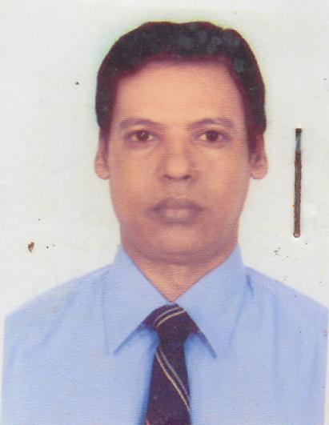 | DR. PROVAT KUMAR BALA  F/Name: Mahadeb Chandra Bala  M/Name: Renuka Bala  BM & DC Reg. No: 17449  NID: 7917631461340  Cell: 01711183363  Address: 701, Sadar Hospital Road, Comilla  Blood Group: AB+
224 | Voter No  LM-1200220 | DR. S. M. MUSTAFIZUR RAHMAN  F/Name: S. M. Mosharof Hossain  M/Name: Mrs. Suraiya Begum  BM & DC Reg. No: 44857  NID: 1926714102814  Cell: 01713485227  Address: Director-Diamond Medical Service, Ramghat, Kandirpar, Comilla  Blood Group: A+
225 | Voter No  LM-1200221  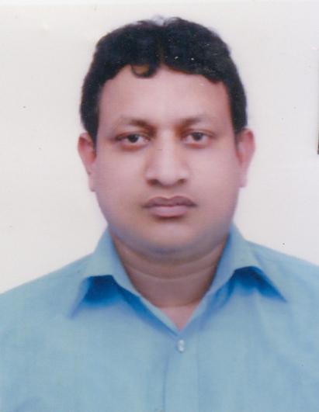 | DR. MD. BODRUDDOZA  F/Name: Md. Bazlul Karim  M/Name: Bilkis Akter  BM & DC Reg. No: 49616  NID: 1926703015197  Cell: 0171273256  Address: Comilla Diabetic Hospital, Comilla  Blood Group: A+
226 | Voter No  LM-1200222  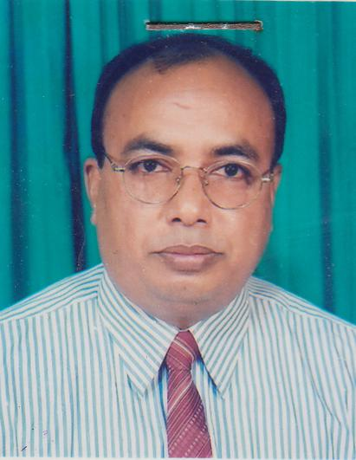 | DR. MUHAMMAD YOUSUF  F/Name: Late. Md. Syedur Rahman  M/Name: Late. Lutfun Nahar  BM & DC Reg. No: 13284  NID:  Cell: 01712247217  Address: UH&FPO, Upazilla Health Complex, Chandina, Comilla  Blood Group: B+
227 | Voter No  LM-1200223  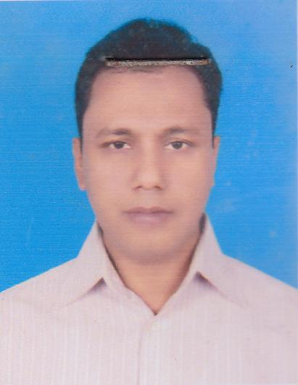 | DR. AHAMMED KABIR  F/Name: Late. Md. Abdul Mannan  M/Name: Anowara Begum  BM & DC Reg. No: 26467  NID: 1922705027509  Cell: 01716587456  Address: Resident Medical Officer, Upazilla Health Complex, Chandina, Comilla  Blood Group: A+
228 | Voter No  LM-1200224  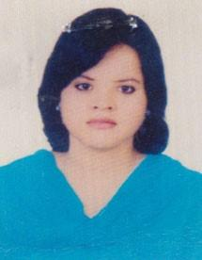 | DR. TANSHINA AFRIN  F/Name: Md Mostafa Khaled  M/Name: Kohinoor Sultana  BM & DC Reg. No: 50290  NID:  Cell:  Address: Mijan Villa- C/O Mijanur Rahman, Bashontopur, Gallai, Chandina, Comilla  Blood Group:
229 | Voter No  LM-1200225  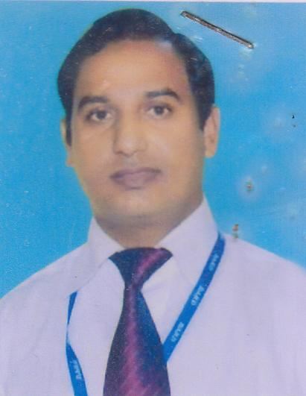 | DR. MD. ASRAF UL MATIN SAGOR  F/Name: Md. Abdul Matin  M/Name: Nazmun Nahar  BM & DC Reg. No: 38328  NID: 2694812102334  Cell: 01711987212  Address: Toru Chhaya, 1157, West Race Corse, Comilla  Blood Group: A+
230 | Voter No  LM-1200226  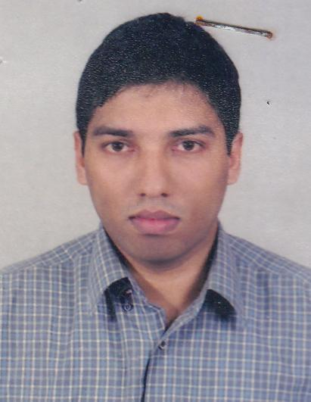 | DR. MOHAMMED NAZMUL AHSAN  F/Name: Dr. Rafiqul Hossain  M/Name: Rowshan Ara Begum  BM & DC Reg. No: 40049  NID: 1927204697221  Cell: 01720583121  Address: Momotamoye Hospital (Pvt.) Ltd. Uttar Laksam, Laksam, Comilla  Blood Group: A+
231 | Voter No  LM-1200227  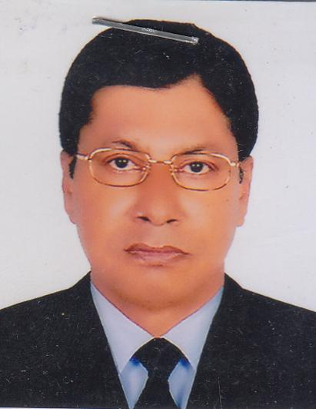 | DR. JAHANGIR HOSSAIN BHUIYAN  F/Name: Late. Mr. Joynal Abedin Bhuiyan  M/Name: Late. Mrs. Jaheda Akhter  BM & DC Reg. No: 13536  NID:  Cell: 01711953170  Address: Professor, Radiotherapy & Cancer Dept., Comilla Medical College  Blood Group: B+
232 | Voter No  LM-1200228  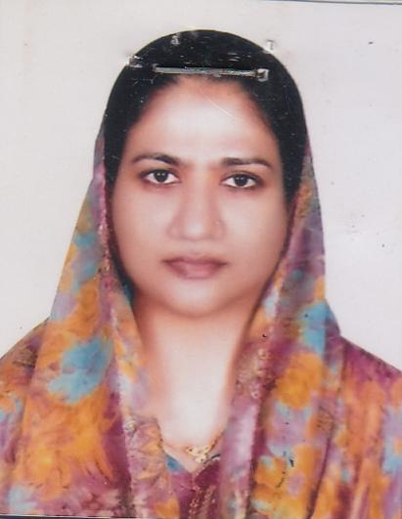 | DR. SHAHNAZ AFRIN  F/Name: Shamsul Arfin Patwari  M/Name: Late. Rashida Begum  BM & DC Reg. No: 18153  NID: 1926710069799  Cell: 01552464774  Address: Panchadeep (2nd Floor), Holding: 425, Shahsuja Mosque Road, Moghaltuli, Comilla  Blood Group: O+
233 | Voter No  LM-1200229 | DR. SUDIP SAHA  F/Name: Dr. Saral Kumar Saha  M/Name: Dr. Molina Rani Kundu  BM & DC Reg. No: 56796  NID: 1926710070199  Cell: 01714439979  Address: 401 (Kha), 1 No. Kandirpar, Shishu Mangal Road, Comilla  Blood Group: B+
234 | Voter No  LM-1200230  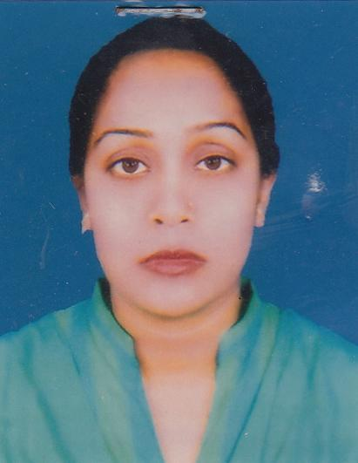 | DR. SAIMA HOQUE  F/Name: Late. Md. Shamsul Hoque  M/Name: Aleya Hoque  BM & DC Reg. No: 39890  NID: 1926712082785  Cell: 01710466924  Address: Medical Officer, Dawlatpur Union Subcentre, Sadar, Comilla  Blood Group: A+
235 | Voter No  LM-1200231  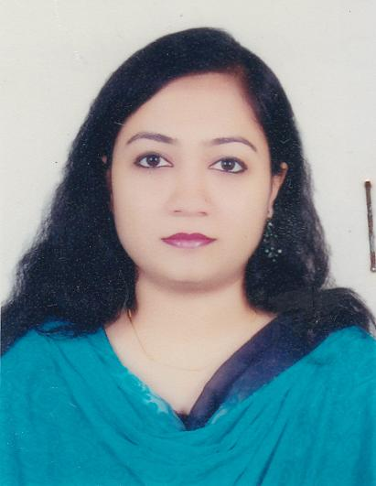 | DR. AFRINA ISLAM  F/Name: Md. Aminul Islam  M/Name: Halena Begum  BM & DC Reg. No: 55205  NID: 1926704028645  Cell: 01746677444  Address: 526, Silver Afia Garden, Doctor Para, Badurtala, Comilla (MMCMC)  Blood Group: O+
236 | Voter No  LM-1200232  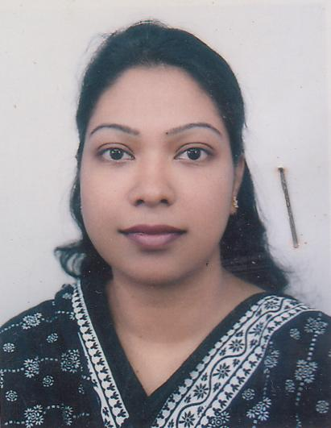 | DR. SHAILA ALAM  F/Name: Dr. Md. Shamsul Alam  M/Name: Mrs. Laila Alam  BM & DC Reg. No: 44256  NID: 1926708136994  Cell: 01819876111  Address: MO, Bagmara Sub. Centre, Sadar South Comilla  Blood Group: O+
237 | Voter No  LM-1200233  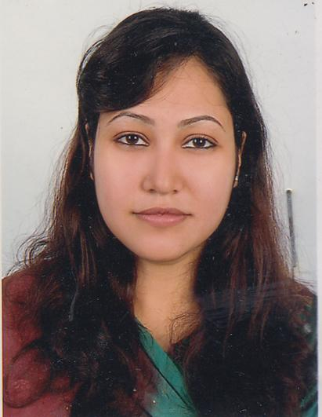 | DR. SHARMIN KHAN  F/Name: Liakat Ali Khan  M/Name: Rafeeya Akhter  BM & DC Reg. No: 51544  NID:  Cell: 01715988062  Address: Ananna Bishrupur, Comilla  Blood Group:
238 | Voter No  LM-1200234  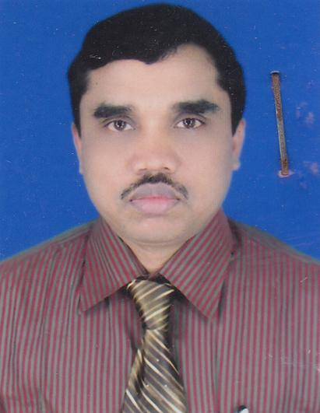 | DR. MRINAL KANTI DHALI  F/Name: Late. Makhan Lal Dhali  M/Name: Priya Bala Dhali  BM & DC Reg. No: 28028  NID: 1926708057539  Cell: 01714135624  Address: Ami Eye Care Centre, Nazrul Avenue, Ranir Bazar, Comilla  Blood Group: AB+
239 | Voter No  LM-1200235  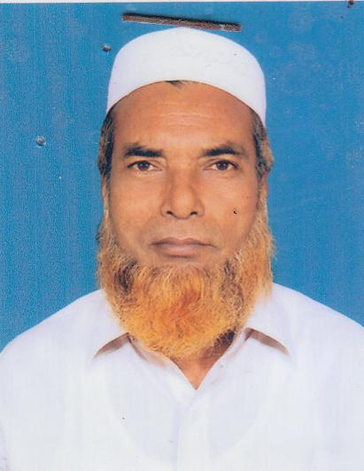 | DR. MD. SHAHID UDDIN  F/Name: Late. Nur Mohammad Molla  M/Name: Tohurer Nesa  BM & DC Reg. No: 6642  NID: 1923306317362  Cell: 01717204481  Address: Naogaon Chowmuhani, South Ashrafpur, Sadar South, Comilla  Blood Group: O+
240 | Voter No  LM-1200236 | DR. MOHAMMAD ABDUL AWAL SOHAIL  F/Name: Mohammad Manik Miah  M/Name: Mrs. Aleya Manik  BM & DC Reg. No: 42952  NID: 1926710065563  Cell: 01712566590  Address: 809, 2nd Floor, South Bagichagaon, Comilla  Blood Group: O+
241 | Voter No  LM-1200237  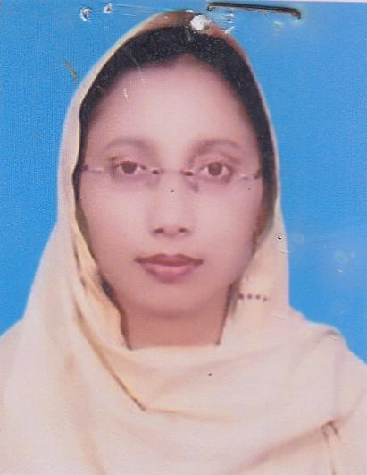 | DR. NAZMA MAZUMDER LIRA  F/Name: M. A. Rajhid Mazumder  M/Name: Mrs. Ayesha Mazumder  BM & DC Reg. No: 42951  NID: 1926710065335  Cell: 01712979442  Address: 809, 2nd Floor, South Bagichagaon, Comilla  Blood Group: AB+
242 | Voter No  LM-1200238  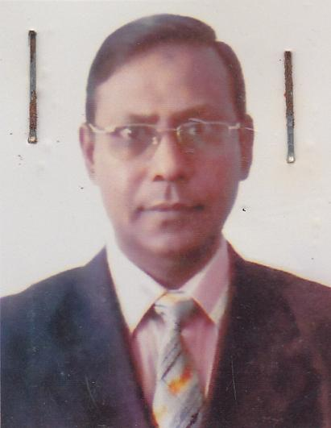 | DR. MD. NAZMUS SAADAT  F/Name: Prof. Dr. Md. Sadeque  M/Name: Mrs. Lutfunnessa  BM & DC Reg. No: 14257  NID: 1926708052989  Cell: 01711079340  Address: Asst. Prof. Eye. Comilla Medical College, Comilla  Blood Group: A+
243 | Voter No  LM-1200239 | DR. SASANKA SHEKHAR MONDAL  F/Name: Monoranjan Mondal  M/Name: Uma Rani Mondal  BM & DC Reg. No: 46200  NID: 7312588960  Cell: 01751689577  Address: Grameen Medical Services, Sadar Hospital Road, Comilla  Blood Group: B+
244 | Voter No  LM-1200240  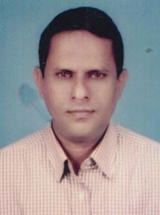 | DR. MUSLEN UDDIN AHMED  F/Name: Abdus Samad  M/Name: Anowara Begum  BM & DC Reg. No: 20020  NID:  Cell: 01711447248  Address: Shatabdi, Shisu Mongal Road, Badurtoal, Comilla  Blood Group:
245 | Voter No  LM-1200241  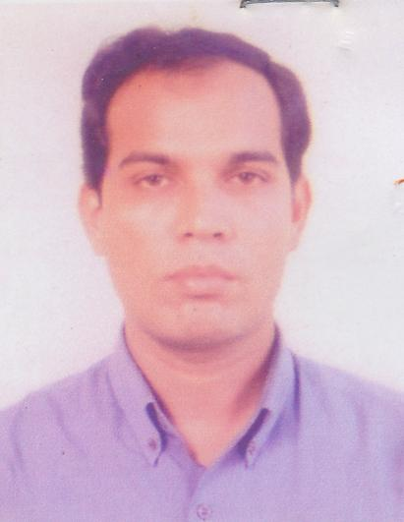 | DR. DIPANKAR LODH  F/Name: Mr. Chitta Ranjan Lodh  M/Name: Mrs. Gitanjoli Lodh  BM & DC Reg. No: 27903  NID: 1926711075324  Cell: 27903  Address: Jn. Consultant, Dept. of ENT, Comilla Medical College Hospital, Comilla  Blood Group: A+
246 | Voter No  LM-1200242  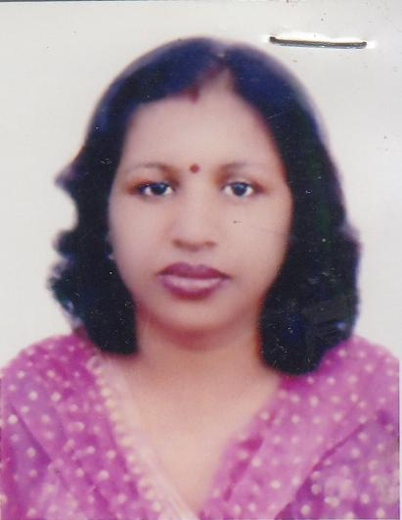 | DR. RITA MAJUMDER  F/Name: Kalipada Majumder  M/Name: Dipali Majumder  BM & DC Reg. No: 48835  NID: 192671107523  Cell: 01712202608  Address: Chest Disease Clinic, Comilla  Blood Group: A+
247 | Voter No  LM-1200243  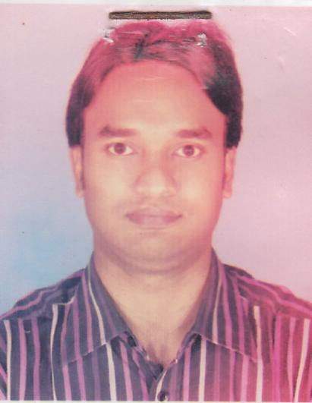 | DR. MD. MASUD HASAN  F/Name: Md. Humayun Kabir  M/Name: Suraiya Begum  BM & DC Reg. No: 52646  NID: 1920902084223  Cell: 01734362745  Address: Upazilla Health Complex, Nagolkoat, Comilla  Blood Group: O+
248 | Voter No  LM-1200244  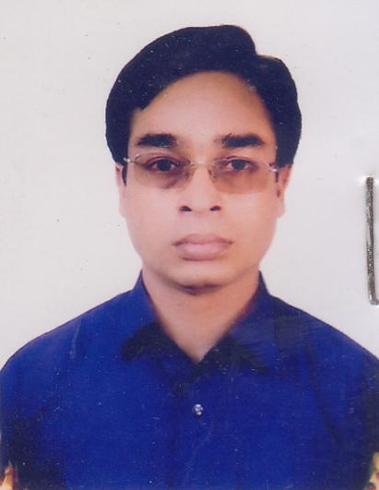 | DR. MD. JAHANGIR ALAM MAZUMDER  F/Name: Md. Moklesur Rahaman Mazumder  M/Name: Mrs. Sultana Razia  BM & DC Reg. No: 22118  NID: 1926713095901  Cell: 01711785070  Address: Jr. Consultant (ENT), UHC Nagolkot, Comilla  Blood Group: O+
249 | Voter No  LM-1200245  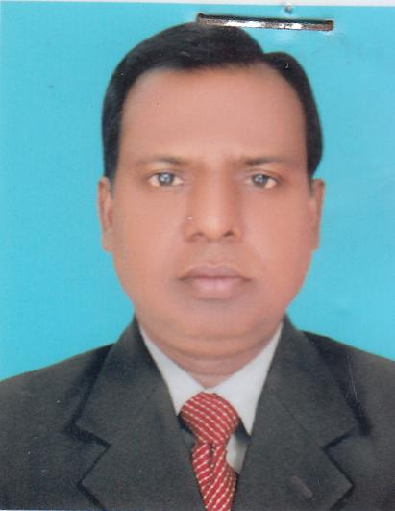 | DR. MD. SHAH ALAM MOLLAH  F/Name: Jamal Md. Zayedul Hoque Mollah  M/Name: Late. Mrs. Zayeda Begum  BM & DC Reg. No: 21284  NID:  Cell: 01819127485  Address: UHC, Homna, Comilla  Blood Group: n_a
250 | Voter No  LM-1200246  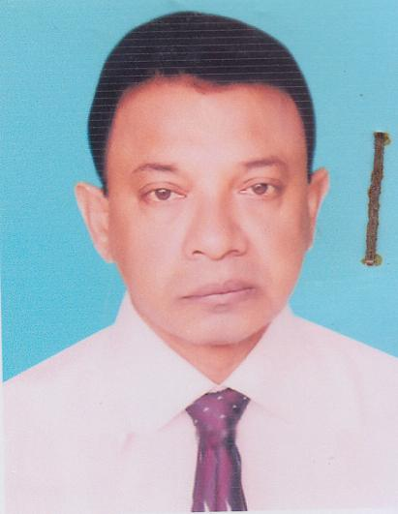 | DR. MD. ABUL HASANAT BHUIYAN  F/Name: Md. Abdul Karim Bhuiyan  M/Name: Mofida Khatun  BM & DC Reg. No: 13156  NID: 1926708056110  Cell: 01558842553  Address: Upazilla Health & Family Planning Officer, Barura, Comilla  Blood Group: O+
251 | Voter No  LM-1200247 | MOHAMMED IQBAL HOSSAIN  F/Name: Md. Abbas Ali  M/Name: Halima Khatun  BM & DC Reg. No: 31902  NID: 1910912278729  Cell: 01711982380  Address: RMO, Upazilla Health Complex, Barura, Comilla  Blood Group: O+
252 | Voter No  LM-1200248  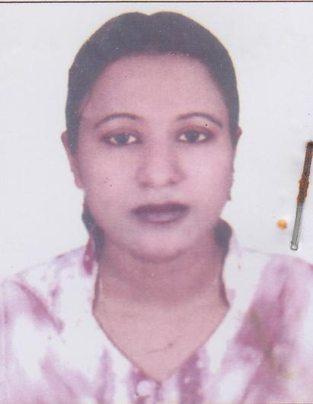 | DR. MOST. MAHFUZA KHATUN  F/Name: Maulana Amanat Ullah  M/Name: Noorjahan  BM & DC Reg. No: 43477  NID: 1910912278730  Cell: 01711979079  Address: Asst. Surgeon, Deora (N), Union H&FWC Barura, Comilla  Blood Group: AB+
253 | Voter No  LM-1200249 | DR. MOHAMMED SHARIFUL ABEDIN KAMOL  F/Name: Dr. Mohammed Zainul Abedin  M/Name: Hamida Begum  BM & DC Reg. No: 43170  NID: 1926704028465  Cell: 01710938636  Address: Asst. Surgeon, Bhabanipur Union Health & FWC, Barura, Comilla  Blood Group: AB+
254 | Voter No  LM-1200250  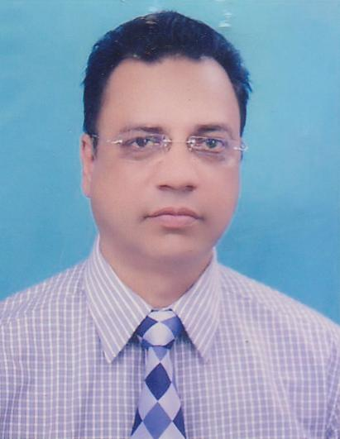 | DR. A K M SHAMEEM  F/Name: Md. Saidul Hoque  M/Name: Begum Dil Afroze  BM & DC Reg. No: 17832  NID: 1926708054724  Cell: 01678175051  Address: Comilla Medical Centre (Pvt.) Ltd. Comilla Tower, Laksam Road, Comilla (RMO)  Blood Group: A+
255 | Voter No  LM-1200251  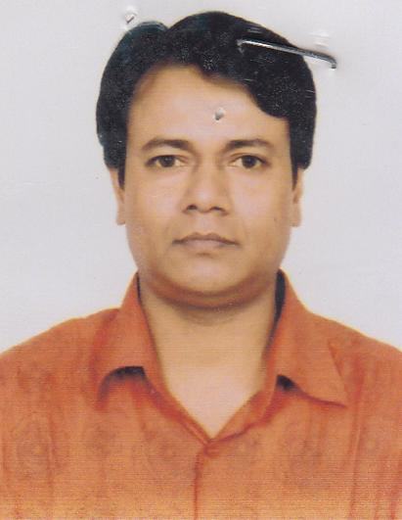 | DR. SYED NAZRUL ISLAM  F/Name: Syed Fazlur Rahman  M/Name: Mrs. Zohora Begum  BM & DC Reg. No: 19260  NID: 1926708052522  Cell: 01711843921  Address: Panasia Diagnostic Centre, Race Course, Badsha Miah Bazar, Comilla  Blood Group: A+
256 | Voter No  LM-1200252  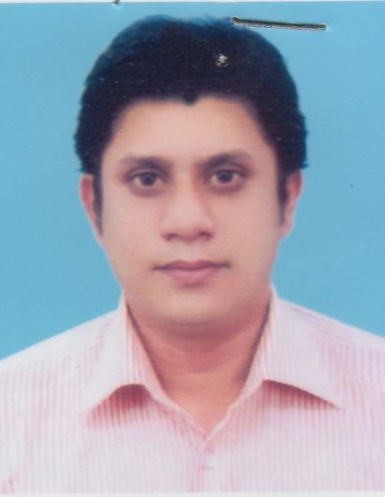 | DR. MD. SYEDUZZAMAN AKHAND  F/Name: Dr. Abdul Quddus Akhand  M/Name: Ayesha Begum  BM & DC Reg. No: 47947  NID: 1926709061613  Cell: 01678175008  Address: Mukti Hospital, Racecourse, Comilla  Blood Group: B+
257 | Voter No  LM-1200253  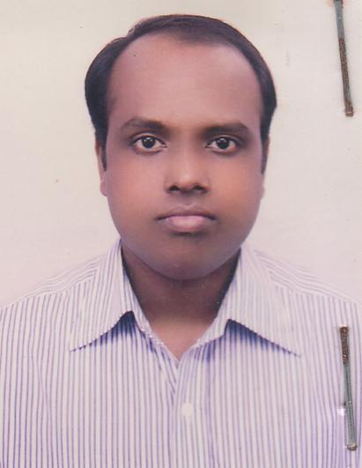 | DR. MOHAMMAD KHAZA AHAMMED  F/Name: Mohammad Shiddiqur Rahman  M/Name: Manwara Begum  BM & DC Reg. No: 39273  NID: 1926709061612  Cell: 01714057720  Address: 398, Bagichagaon, Comilla  Blood Group: B+
258 | Voter No  LM-1200254  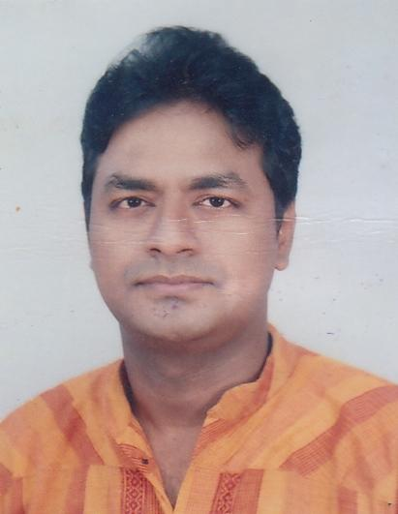 | DR. MD. ARIF MURSHED KHAN  F/Name: Md. Anisul Haque Khan  M/Name: Professor Zohara Anis  BM & DC Reg. No: 31330  NID: 1926710070425  Cell: 01711382480  Address: Greenwood Valley, Jhawtala, Comilla  Blood Group: B+
259 | Voter No  LM-1200255  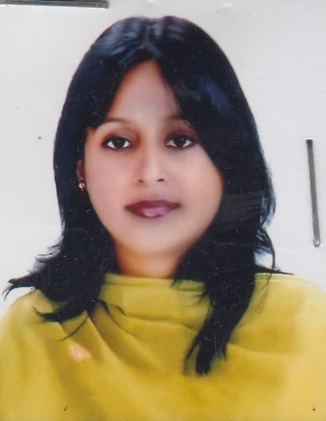 | DR. ATISHA RABBI  F/Name: A. M. M. Reza-E-Rabbi  M/Name: Hena Mansur  BM & DC Reg. No: 43552  NID: 2696827837018  Cell: 01732988984  Address: Greenwood Valey, Jhawtala, Comilla  Blood Group: A+
260 | Voter No  LM-1200256  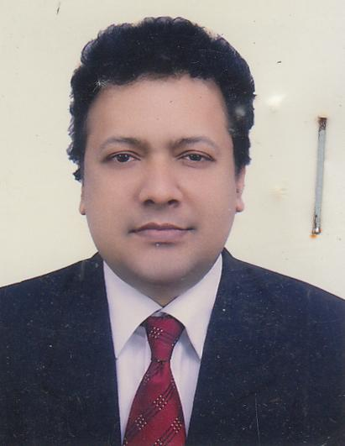 | DR. JOYDEEP DATTA GUPTA  F/Name: Debabrata Datta Gupta  M/Name: Purabi Datta Gupta  BM & DC Reg. No: 23435  NID: 2692620393865  Cell: 01711825052  Address: Asst. Prof. of Pathology, Comilla Medical College  Blood Group: A+
261 | Voter No  LM-1200257  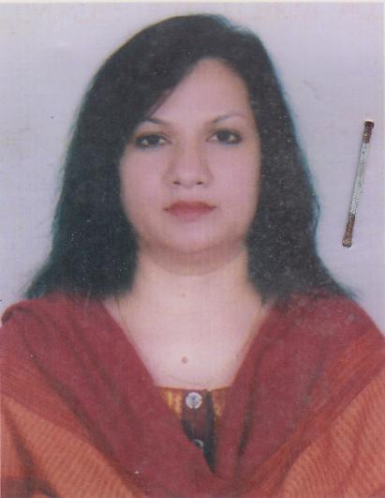 | DR. SHILPI DATTA GUPTA  F/Name: Suvas Chandra Nandy  M/Name: Monju Nandy  BM & DC Reg. No: 25732  NID: 2692620393866  Cell: 01714395777  Address: Sonologist, Medinova Medical Service, Comilla  Blood Group: O+
262 | Voter No  LM-1200258  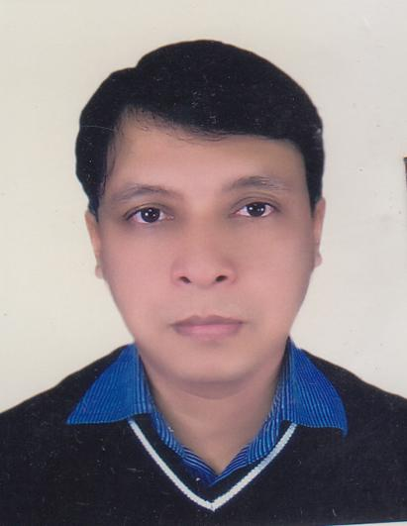 | DR. MD. BILALUL ISLAM  F/Name: Md. Mynul Islam  M/Name: Mrs. Sufia Islam  BM & DC Reg. No: 26204  NID: 2696352220145  Cell: 01711147405  Address: Zarzas Residential Area, Kandirpar, Comilla  Blood Group: AB+
263 | Voter No  LM-1200259  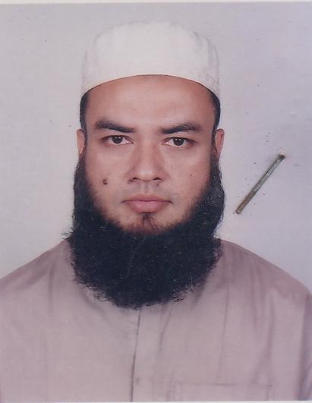 | DR. ZUBAYEDUR AHMAD  F/Name: Abdul Quddus  M/Name: Kazi Masuda Begum  BM & DC Reg. No: 29807  NID: 1926717120465  Cell: 01712531142  Address: Resident Surgeon, Comilla Medical College Hospital  Blood Group: O+
264 | Voter No  LM-1200260  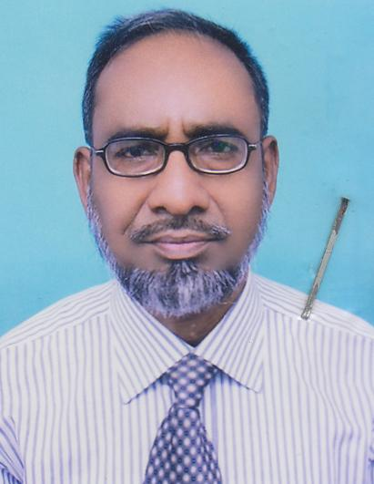 | DR. MD. ABDUL MANNAN  F/Name: Late. Alimuddin Sarker  M/Name: Late. Tosiron Nessa  BM & DC Reg. No: 9705  NID: 1926710068069  Cell: 01732094306  Address: Associate Professor, Dermatology, Comilla Medical College  Blood Group: A+
265 | Voter No  LM-1200261  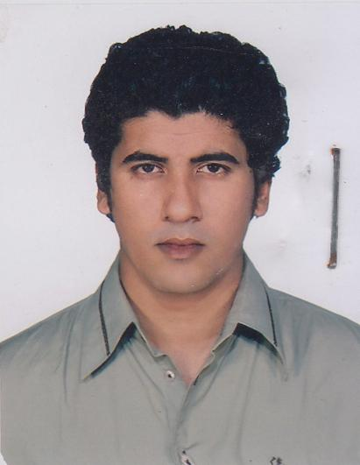 | DR. AMIT SINHA  F/Name: Bishnupada Sinha  M/Name: Lovely Ghose  BM & DC Reg. No: 54399  NID: 1926708053191  Cell: 01711447910  Address: Monika, 484/532, Thakurpara Bagan Bari, Comilla  Blood Group: O+
266 | Voter No  LM-1200262  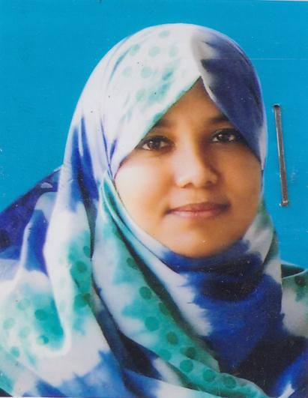 | DR. RASHEDA AKHTER  F/Name: Md. Abdul Khaleque  M/Name: Mrs. Anowara Begum  BM & DC Reg. No: 40923  NID: 2699040700845  Cell:  Address: RMO, Comilla Medical College Hospital, Comilla  Blood Group: O+
267 | Voter No  LM-1200263  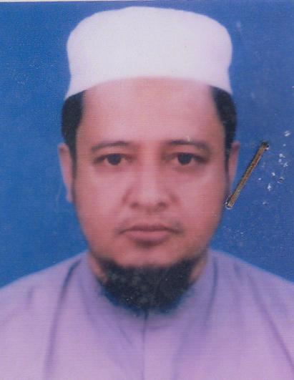 | DR. SHAMSHER AHMED  F/Name: Abdul Quddus  M/Name: Kazi Masuda Begum  BM & DC Reg. No: 23945  NID: 1926717120549  Cell: 01711319098  Address: Darul Akram, Telokona, Sahapara, Comilla  Blood Group: O+
268 | Voter No  LM-1200264 | MD ASHIK SALAUDDIN  F/Name: A. K. M. Mamun Ur Rashid  M/Name: Hosne Ara Begum  BM & DC Reg. No: 43530  NID: 2695434990294  Cell: 01711900914  Address: h-18,road-2,shadinota Shoroni,Uttar Badda,Dhaka-1212  Blood Group: AB+
269 | Voter No  LM-1200265  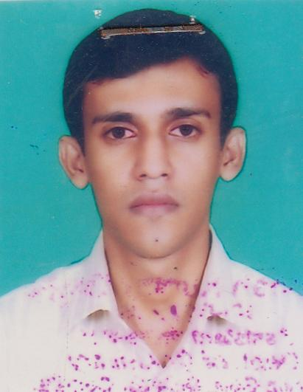 | DR. ANUPAM PAL  F/Name: Nani Gopal  M/Name: Reba Rani Das  BM & DC Reg. No: 51660  NID: 1926711076339  Cell: 01819112154  Address: IMO, Cardiology, Comilla Medical College  Blood Group: n_a
270 | Voter No  LM-1200266 | DR. MOHAMMAD ARIF HAIDER  F/Name: Late. A. M. Sujat Ali  M/Name: Late. Shamsoon Nahar  BM & DC Reg. No: 45691  NID: 5550100030412090  Cell: 01819102312  Address: Haider Palace, 63, Bagichagaon, Comilla  Blood Group: B-
271 | Voter No  LM-1200267  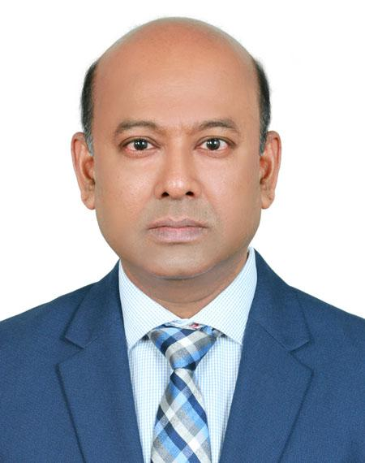 | DR. MEAH MONJUR AHMED  F/Name: A. M. Abdul Quader  M/Name: Saleha Khatoon  BM & DC Reg. No: 22622  NID: 19671926710071997  Cell: 01711444370  Address: Apartment # 5D, SEL Fatema Jahanara Tower, 629 & 631 Jhawtala, Cumilla.  Blood Group: B+
272 | Voter No  LM-1200268 | DR. MD. HABIBUNNABI ASHIQUR RAHAMAN  F/Name: Md. Rahamat Ali  M/Name: Suraiya Sultana  BM & DC Reg. No: 50876  NID: 19821916794000003  Cell: 01714398415  Address: Comilla Medical College Hossain  Blood Group: B+
273 | Voter No  LM-1200269 | DR. FARHAD UDDIN AHMED BHUIYAN  F/Name: Auhi Uddin Ahmed Bhuiyan  M/Name: Kazi Faizunnea Begum  BM & DC Reg. No: 38535  NID: 1926708055005  Cell: 01816583249  Address: Birotee 666, A Salam Road, South Thakurpara, Comilla-3500  Blood Group: O+
274 | Voter No  LM-1200270  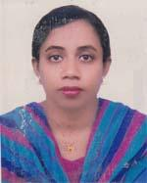 | DR. TALEYA CHOWDHURY  F/Name: Abdul Mobin  M/Name: Amina Begum  BM & DC Reg. No: 38536  NID: 1926708055007  Cell: 01816583250  Address: Birotee 666, A Salam Road, South Thakurpara, Comilla-3500  Blood Group: O+
275 | Voter No  LM-1200271  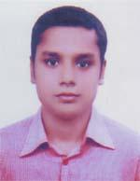 | DR. KHAJA MORSHED MAHMUD  F/Name: Khaja Mohammad Ali  M/Name: Delwara Begum  BM & DC Reg. No: 64841  NID: 1916751232737  Cell: 01716242536  Address: Medical Officer , Delta Hospital (Pvt.) Limited, Comilla  Blood Group: B+
276 | Voter No  LM-1200272  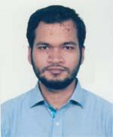 | DR. MD. ATAUR RAHMAN SOHEL  F/Name: Late Md. Fazlur Rahman  M/Name: Habiba Rahman  BM & DC Reg. No: 73746  NID: 19911996701000036  Cell: 01723797725  Address: Habiba villa-263/K, Bishnupur, 167 Simitari Road, Kotwali, Comilla.  Blood Group: O+
277 | Voter No  LM-1200273  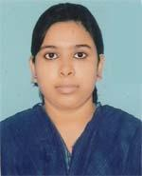 | DR. NAZIA BINTE ALAM  F/Name: Dr. Md. Jahangir Alam  M/Name: Dr. Nasreen Akter Banu  BM & DC Reg. No: 59655  NID: 1926712081848  Cell: 01717335121  Address: 102, North Chartha, Comilla  Blood Group: AB+
278 | Voter No  LM-1200274  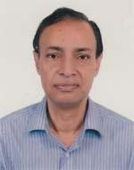 | DR. MD. MIZANUR RAHMAN  F/Name: Late Shafiuddin Ahmed  M/Name: Latifa Khatoon  BM & DC Reg. No: 11044  NID: 1926713090750  Cell: 01707432609  Address: Lakhi House, Laksam Road, South Chartha, Comilla  Blood Group: AB+
279 | Voter No  LM-1200275  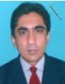 | DR. MOHAMMAD ANWARUL ISLAM  F/Name: Mohammad Nurul Islam  M/Name: Anwara Islam  BM & DC Reg. No: 54564  NID:  Cell: 01712267379  Address: Shabuj Chata Clinic Uttar Bazar Laksham, Comilla  Blood Group: A+
280 | Voter No  LM-1200276  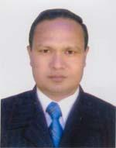 | DR. HEMANTO KUMAR ROY  F/Name: Late Prio Nath Roy  M/Name: Bijo Bala  BM & DC Reg. No: 26264  NID:  Cell: 01712255362  Address: Hemanto Eye Care, Kardir Par, Comilla, (Opposit Trawna Center)  Blood Group: A+
281 | Voter No  LM-1200277 | DR. MOHAMMED KAMAL HOSSAIN  F/Name: Late Mohammed Abdul Latif  M/Name: Razia Begum  BM & DC Reg. No: 27493  NID: 1926703019597  Cell: 01712000122  Address: 1353, North Race Course, Comilla  Blood Group: O-
282 | Voter No  LM-1200278 | DR. MOHAMMED EMDADUL HOQUE  F/Name: Md. Sekander Ali  M/Name: Mohsena Khanum Chowdhury  BM & DC Reg. No: 62701  NID: 1926711079228  Cell: 01739178608  Address: 47, North-West Corner of Nanua Dighi, Comilla-3500  Blood Group: B+
283 | Voter No  LM-1200279 | DR. MAINUDDIN AHMED  F/Name: Giasudddin Ahmed  M/Name: Syeda Tahera Khatun  BM & DC Reg. No: 23382  NID: 1926704027430  Cell: 01819446059  Address: 4-C Samatot Legecy  Blood Group: A+
284 | Voter No  LM-1200280 | DR. MOHAMMAD MASUM HASAN  F/Name: Mohammad Abdur Razzak  M/Name: Late Rokeya Begum  BM & DC Reg. No: 35987  NID: 1916768292217  Cell: 01819285902  Address: Asst. Prof. Urolgy, Comilla Medical College  Blood Group: B+
285 | Voter No  LM-1200281  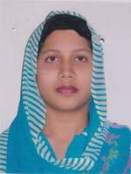 | DR. TASLIMA BEGUM  F/Name: Abdul Mannan Molla  M/Name: Rabeya Khanom  BM & DC Reg. No: 35986  NID: 1916768292218  Cell: 01819230120  Address: Junion Consultant, Gynee & Obs, Brahmmanpur Health Complex, Comilla  Blood Group: O+
286 | Voter No  LM-1200282  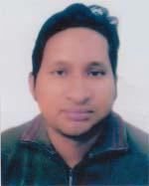 | DR. ATIQUR RAHMAN  F/Name: Late Khurshiqur Rahman  M/Name: Monowara Begum  BM & DC Reg. No: 52614  NID: 9196213253087  Cell: 01714728851  Address: Akhond Tower 4th Floor, EPZ Road, Saddir Dokhin, Comilla  Blood Group: A+
287 | Voter No  LM-1200283 | DR. MIRZA MOHAMMAD TYEABUL ISLAM  F/Name: Mirza Nurul Islam  M/Name: Momena Islam  BM & DC Reg. No: 31274  NID: 2693625799842  Cell: 01717435212  Address: Golderbari-2, Ramghat, Kandir Par, Comilla-3500  Blood Group: B+
288 | Voter No  LM-1200284 | DR. ABU MOHAMMAD HASAN  F/Name: Md. Nurul Islam  M/Name: Monowara Begum  BM & DC Reg. No: 54202  NID:  Cell: 01749046090  Address: Amena Medical Centre, Laksam , Comilla  Blood Group: A+
289 | Voter No  LM-1200285  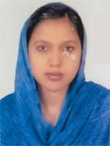 | DR. BILKIS SULTANA PANNA  F/Name: Khondaker Afzalur Rahman  M/Name: Anowara Begum  BM & DC Reg. No: 43078  NID: 1913110530118  Cell: 01715438534  Address: Momotamoyae Hospital (Pvt.) Ltd. Uttar Bazar, Laksam  Blood Group: B+
290 | Voter No  LM-1200286  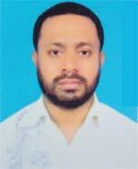 | DR. MD. KAWSAR HOSSAIN  F/Name: Mui Abdul Quader  M/Name: Mrs. Morium Quader  BM & DC Reg. No: 25226  NID: 1325803997727  Cell: 01815141813  Address: 593/02, South Thakurpara, Comilla  Blood Group: B+
291 | Voter No  LM-1200287  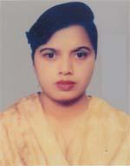 | DR. SANGITA BISWAS  F/Name: Mr. B.n Biswas  M/Name: Mrs. Subhra Biswas  BM & DC Reg. No: 25475  NID: 2627205652278  Cell: 01712206323  Address: Comillam EPZ Medical Centre, Comilla, 3000  Blood Group: O+
292 | Voter No  LM-1200288  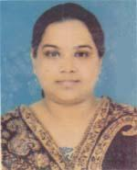 | DR. SANJIDA AFROZ  F/Name: Kazi Amirul Islam  M/Name: Morsheda Akter  BM & DC Reg. No: 44858  NID: 2695434051097  Cell: 01938277511  Address: Sufi Monzil 2nd Muradpur, Bhujyapukurpar, Comilla  Blood Group: O+
293 | Voter No  LM-1200289  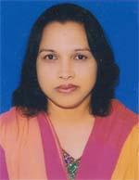 | DR. SAIMA AFROZ  F/Name: Manwarul Islam  M/Name: Kamrunnesa  BM & DC Reg. No: 30004  NID: 2696654283848  Cell: 01711355383  Address: Eastern Med. College, Comilla  Blood Group: B+
294 | Voter No  LM-1200290  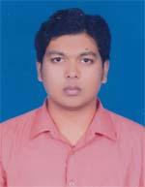 | DR. AZHARUL ISLAM  F/Name: Md. Nurul Islam  M/Name: Hosneara Begum  BM & DC Reg. No: 66489  NID: 1916765149479  Cell: 01731194279  Address: Kucaitoli, Adarsha Sadar, Comilla  Blood Group: B+
295 | Voter No  LM-1200291  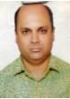 | DR. MOHAMMAD MAHFUZUR RAHMAN  F/Name: Md.ali Akram  M/Name: Noorunnahar  BM & DC Reg. No: 37247  NID:  Cell: 017112700651  Address: Eastern Medicl College, Comilla  Blood Group: A+
296 | Voter No  LM-1200292  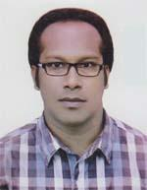 | DR. A. K. M. HELAL MORSHED  F/Name: Md. Abdul Kashem  M/Name: Selin Akter  BM & DC Reg. No: 64858  NID: 1926714100349  Cell: 01716614548  Address: Comilla Rniversity Medical Centre, Kotbari, Comilla  Blood Group: O+
297 | Voter No  LM-1200293 | DR. MD. NAJMUL HASAN  F/Name: Md. Habib Ullah  M/Name: Begum Rabeya  BM & DC Reg. No: 62827  NID: 1926711077097  Cell: 01912927104  Address: Upazilla Health Complex, Adarsha Sadar, Comilla  Blood Group: A+
298 | Voter No  LM-1200294 | DR. KAMRUL HASAN  F/Name: Md. Abdul Hai Bhuiyan  M/Name: Mst. Jahanara Begum  BM & DC Reg. No: 44769  NID: 1926702006302  Cell: 01911112161  Address: 610/4, Naz View, Chotora Westpara, Comilla  Blood Group: O+
299 | Voter No  LM-1200295  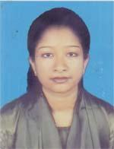 | DR. FARAH KARNINE SILVA  F/Name: Md. Sayeed Ali  M/Name: Parveen Malek  BM & DC Reg. No: 55489  NID: 2697556393147  Cell: 01716119320  Address: h-171B, Block-C, Section-2, Comilla Housing Estate, Comilla  Blood Group: A+
300 | Voter No  LM-1200296 | DR. RIAZ AHMED SAKIL  F/Name: Late Md. Anowar Ullah  M/Name: Umme Kulsum  BM & DC Reg. No: 33988  NID: 3022905111870  Cell: 01711345641  Address: House: 17/B, Block-c, Section-2, Comilla Housing Estate, Comilla  Blood Group: A+
301 | Voter No  LM-1200297 | DR. DURLAV KANTI PAUL  F/Name: Jagadish Chandra Paul  M/Name: Swapna Rani Paul  BM & DC Reg. No: 71380  NID: 1991197207000043  Cell: 01718357296  Address: Vill-Dhamaicha, Post-Laksam, Dist-Comilla  Blood Group: B+
302 | Voter No  LM-1200298  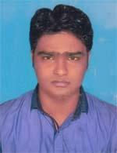 | DR. SABBIR AHMED SIDDIKI  F/Name: Md. Abdul Awal  M/Name: Rabeya Akter  BM & DC Reg. No: 74744  NID: 1926702008488  Cell: 01718657038  Address: Hate Babul\'s House, Chotona Maddha Para, Semitary Road, Comilla Sadar, Comilla  Blood Group: B+
303 | Voter No  LM-1200299  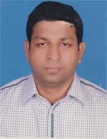 | DR. MAKHAN LAL PAUL  F/Name: Hari Mohan Paul  M/Name: Milon Bala Paul  BM & DC Reg. No: 31513  NID: 2697557397379  Cell: 01712090152  Address: Sel Sabiya Heights Police Line, Comilla  Blood Group: AB+
304 | Voter No  LM-1200300  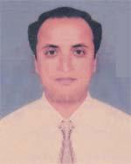 | DR. MAHMUDUL HASAN KHAN  F/Name: A. U. M. Shahid Ullah Khan  M/Name: Halima Khanam  BM & DC Reg. No: 34196  NID: 2694264728581  Cell: 01711033674  Address: Comilla University Medical Centre  Blood Group: O+
305 | Voter No  LM-1200301  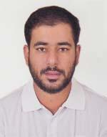 | DR. AFSHAN ANIS  F/Name: Dr. Abdul Baki Anis  M/Name: Mrs. Nasreen Anis  BM & DC Reg. No: 65958  NID: 1926703015649  Cell: 01713108724  Address: Sufia Mansion, House-1213, Mafiz Uddin Road, Race Course, Comilla Sadar, 3500  Blood Group: A+
306 | Voter No  LM-1200302  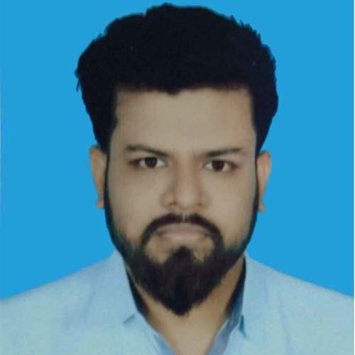 | DR. A. M. IQBAL SHAHREARE  F/Name: Late A. K. M. Abdul Halim  M/Name: Monowara Begum  BM & DC Reg. No: 84719  NID: 1471903698  Cell: 01688503536  Address: House Name-Prottoy, Holding No.-1537/A, North Raucourse, Comilla  Blood Group: A+
307 | Voter No  LM-1200303  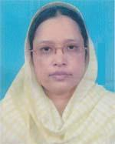 | DR. ARJU MAN ARA BEGUM  F/Name: Abu Baker Md. Siddique  M/Name: Rahila Khatun  BM & DC Reg. No: 17456  NID: 1926710067069  Cell: 01711354443  Address: 428, Nazrul Avenue, Kandirpar, Comilla  Blood Group: O+
308 | Voter No  LM-1200304  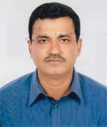 | DR. MOHAMMED SHAFAYET ULLAH  F/Name: Mukther Ahammed  M/Name: Lutfunnessa  BM & DC Reg. No: 34834  NID: 1926703012132  Cell: 01711311554  Address: Holding No.-1345, Mukhter Monzil Noab Miar Goli, North Raucourse, Comilla  Blood Group: O+
309 | Voter No  LM-1200305 | DR. MOHAMMAD JAHNGIR ALAM  F/Name: Late Abdul Goni  M/Name: Noorjahan Begum  BM & DC Reg. No: 41945  NID: 1911863660193  Cell: 01711114376  Address: Rokeya Vill 2nd Murad Pur, Kotwali, Comilla  Blood Group: A+
310 | Voter No  LM-1200306 | DR. NIHAR RANJAN MAZUMDER  F/Name: Late Phani Bhushau Mazumder  M/Name: Late Gita Rani Mazumder  BM & DC Reg. No: 24083  NID: 1926708136980  Cell: 01711313810  Address: Silver Talpukur View, Flat No.-1A, South West Bank of Talpukur, Comilla-3500  Blood Group: A+
311 | Voter No  LM-1200307 | DR. NASRIN AKTER  F/Name: A. T. M. Eunus  M/Name: Mrs. Sayeeda Khatun  BM & DC Reg. No: 45907  NID: 1913339317694  Cell: 01911261793  Address: S.E.L. Jahanar-Fatema Tower, JhawTola, Comilla  Blood Group: A+
312 | Voter No  LM-1200308  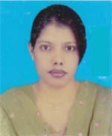 | DR. MST. FARZANA KHONDKER ESHAN  F/Name: Mohammad Moslehuddin Khondker  M/Name: Nazma Jahan  BM & DC Reg. No: 43750  NID: 1926703016184  Cell: 01717637734  Address: 1296, Khelaghar (1st Floor) Racecourse, Comilla  Blood Group: O+
313 | Voter No  LM-1200309 | DR. MUHAMMAD NAZMUL ALAM  F/Name: Muhammad Jahagir Alam  M/Name: Hazera Khatun  BM & DC Reg. No: 55925  NID: 19852610413926289  Cell: 01913188459  Address: UHC. Chauddagram, Comilla  Blood Group: O+
314 | Voter No  LM-1200310 | DR. MD. SAMSUL ISLAM  F/Name: Md. Serajul Islam Mazumder  M/Name: Masuda Begum  BM & DC Reg. No: 51661  NID: 1926708055697  Cell: 01747996500  Address: Doctor\'s Quarter, Upazilla Health Complex, Chauddagram, Comilla  Blood Group: A+
315 | Voter No  LM-1200311  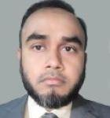 | DR. KAZI ABDUL MOMIN  F/Name: Kazi Abdul Hoque  M/Name: Kazi Saleha Hoque  BM & DC Reg. No: 48444  NID: 1913147512745  Cell: 01815482142  Address: Medical Officer , Upazilla Health Complex, Chauddagram , Comilla  Blood Group: B+
316 | Voter No  LM-1200312 | DR. MOHAMMED MONIRUL ISLAM CHOWDHURY  F/Name: Sherajul Haque Chowdhury  M/Name: Momena Begum  BM & DC Reg. No: 46805  NID: 1913142499107  Cell: 01815000971  Address: R. M. O-UHC-Chauddagram, Comilla  Blood Group: B+
317 | Voter No  LM-1200313  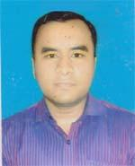 | DR. MD. GOLAM KIBRIA  F/Name: Late Abul Khayer  M/Name: Shahna Akhter  BM & DC Reg. No: 60697  NID: 2694262682428  Cell: 01670839031  Address: M. O. UHC-Chauddagram, Comilla  Blood Group: B+
318 | Voter No  LM-1200314  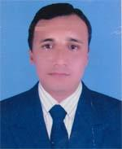 | DR. MD. MIR HOSSAIN  F/Name: Md. Samsul Haque  M/Name: Mrs. Noorjahan Begum  BM & DC Reg. No: 49814  NID: 1911894644210  Cell: 01711204064  Address: UHC, Comilla  Blood Group: B+
319 | Voter No  LM-1200315 | DR. A. N. M. JANE ALAM  F/Name: Md. Abul Kashem  M/Name: Mrs. Monowara Begum  BM & DC Reg. No: 43587  NID: 1926704028777  Cell: 01716444130  Address: 247, Kaptan Bazar (South to Mazar), Comilla-3500  Blood Group: B+
320 | Voter No  LM-1200316  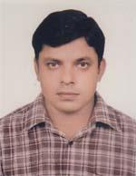 | DR. MOHAMMAD MUSTAFIZUR RAHMAN (MITHU)  F/Name: Md. Mukhlesur Rahman  M/Name: Mrs. Khairun Nahar  BM & DC Reg. No: 43102  NID: 6826012657226  Cell: 01711122070  Address: Sec-2, Block-D, Housing Estate, Comilla  Blood Group: B+
321 | Voter No  LM-1200317  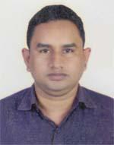 | DR. MD. MONIRUZZAMAN  F/Name: Md. Abdul Malek  M/Name: Mrs. Mazeda Begum  BM & DC Reg. No: 52362  NID: 159411634594  Cell: 01712737689  Address: Vill-Harong, Post-Chaudiua, P.s-Chaudiua, Dist-Comilla  Blood Group: A+
322 | Voter No  LM-1200318  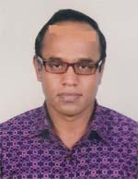 | DR. MD. KAMRUZZAMAN KHOKAN  F/Name: Abdul Monaf  M/Name: Aleya Begum  BM & DC Reg. No: 34456  NID: 2697556418024  Cell: 01714291255  Address: 6/3, Orphanage Road Lalbag, Dhaka, UHC, Laksam, Comilla  Blood Group: O+
323 | Voter No  LM-1200319 | DR. PALASH KUMAR DEY  F/Name: Pijush Kanti Dey  M/Name: Bulbuli Rani Dey  BM & DC Reg. No: 57630  NID: 1926708055596  Cell: 01674860192  Address: Holding No. -508, South East Talpukur Par, Sadar, Comilla  Blood Group: O+
324 | Voter No  LM-1200320  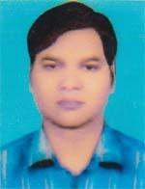 | DR. MOHAMMAD SAHADAT HOSSAIN  F/Name: Mohammad Taharul Islam  M/Name: Salina Begum  BM & DC Reg. No: 31593  NID: 1926713094610  Cell: 01733499889  Address: Civil Surgeon Office, Comilla  Blood Group: A+
325 | Voter No  LM-1200321 | DR. KHONDOKER AL MONSUR HELAL  F/Name: Late Mohammad Chadmiah Khondoker  M/Name: Mrs. Forater Nesa  BM & DC Reg. No: 24272  NID: 1927208640406  Cell: 01711962585  Address: Nil-Padha, (4th Floor), 307, Modina Mosjid Road, Thakurpara, Comilla  Blood Group: O+
326 | Voter No  LM-1200322  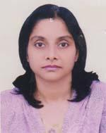 | DR. ZUBAIDA AHMED  F/Name: Zamir Ahmed  M/Name: Jahanara Zamir  BM & DC Reg. No: 22623  NID: 19681926710071998  Cell: 01712031006  Address: Apartment # 5D, SEL Fatema Jahanara Tower, 629 & 631 Jhawtala, Cumilla  Blood Group: O+
327 | Voter No  LM-1200323  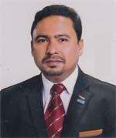 | DR. OMAR FAROQUE  F/Name: Md. Farid Uddin  M/Name: Late Razia Begum  BM & DC Reg. No: 39476  NID: 1926703133547  Cell: 01715028776  Address: Sel Ansar Garden, House-59/53, 11 Jodae Court Road, Comilla  Blood Group: A+
328 | Voter No  LM-1200324  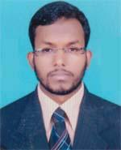 | DR. MD. MOZAMMAL HOQUE  F/Name: Late Md. Momotaz Uddin  M/Name: Mahbuba Khanam  BM & DC Reg. No: 70331  NID: 1926711078010  Cell: 01613456545  Address: North Ashrafpur, Tomsombriz, Comilla  Blood Group: O+
329 | Voter No  LM-1200325 | DR. FAZLUL KABIR  F/Name: AKM Khursed Alam  M/Name: Fatema Khanom  BM & DC Reg. No: 52778  NID: 9196208195933  Cell: 01717021658  Address: Vill-Duria Bisnopur, Post-Duria Bisnopur, P.s-Laksam, Dist-Comilla  Blood Group: O+
330 | Voter No  LM-1200326 | DR. KOUSAR AHMED  F/Name: Ali Ahmed  M/Name: Shirin Akter  BM & DC Reg. No: 66148  NID: 1926713095983  Cell: 01717587745  Address: Shirin Monzil, Holding No.-625/514, South Chartha, Comilla City Corporation, Dist-Comilla  Blood Group: O+
331 | Voter No  LM-1200327 | DR. SAIFUR RAHMAN  F/Name: Shahidur Rahman  M/Name: Selina Akter Begum  BM & DC Reg. No: 55626  NID: 1926709061192  Cell: 01711105202  Address: Bagichagaon, Comilla  Blood Group: B+
332 | Voter No  LM-1200328  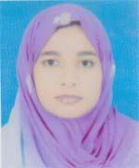 | DR. FARHANA RAHMAN  F/Name: Muslimur Rahman  M/Name: Jaheda Parven  BM & DC Reg. No: 67874  NID:  Cell: 01681710504  Address: 233/215, Rokeya Maternity Clinic, Deyvmburitola, Comilla City Corporation, Dist-Comilla  Blood Group: O+
333 | Voter No  LM-1200329 | DR. MD. ASRAFUL ALAM SIDDIQUE  F/Name: Late Farid Uddin Ahmed  M/Name: Mrs. Shahida Begum  BM & DC Reg. No: 53516  NID: 9196208192831  Cell: 01717497937  Address: 320/1, Monsef Quarter, Kotwali, Comilla  Blood Group: O+
334 | Voter No  LM-1200330 | DR. MOHAMMED AMINUL ISLAM  F/Name: Bazlur Rahman  M/Name: Momtaz Begum  BM & DC Reg. No: 34224  NID: 1923306316294  Cell: 01712520747  Address: Anamica Medical College Road, Tomsombrige, Comilla  Blood Group: A+
335 | Voter No  LM-1200331 | DR. LITON KUMAR ROY  F/Name: Kunja Behari Roy  M/Name: Shefali Rani Roy  BM & DC Reg. No: 23999  NID: 19681595715413662  Cell: 01720969999  Address: Moon Hospital Jhautala, Comilla  Blood Group: O+
336 | Voter No  LM-1200332  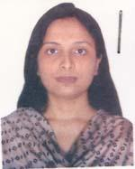 | DR. JEBUNNAHAR  F/Name: Md Anwar Hossain  M/Name: Mrs Ferdousi Akhter  BM & DC Reg. No: 45950  NID: 1926711076761  Cell: 01716359577  Address: 646/2 noorcotage nimtoli monohardur  Blood Group: AB+
337 | Voter No  LM-1200333 | DR. SALEH AHMED  F/Name: Md. Abdur Rashid  M/Name: Mrs. Ankurar Nessa  BM & DC Reg. No: 30038  NID: 1913383410667  Cell: 01715013369  Address: 646/2, Noor Cottage, Nimtoli, Monohar Pur, Comilla  Blood Group: B+
338 | Voter No  LM-1200334 | DR. MD. MIZANUR RAHMAN  F/Name: A. B. M. Abdul Latif  M/Name: Monoara Begum  BM & DC Reg. No: 25956  NID: 1926707047558  Cell: 01716340150  Address: Medical Officer, General Hospital, Comilla  Blood Group: B+
339 | Voter No  LM-1200335  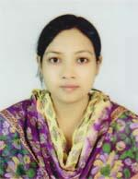 | DR. KAZI ISRAT JAHAN  F/Name: Mabud Meah Kazi  M/Name: Kulsum Akhter  BM & DC Reg. No: 46562  NID: 1926711079893  Cell: 01712730198  Address: Medical Officer, General Hospital, Comilla  Blood Group: A+
340 | Voter No  LM-1200336 | DR. MOHAMMAD ALI  F/Name: Md. Idrish Mia  M/Name: Saleha Begum  BM & DC Reg. No: 40925  NID: 2697556419289  Cell: 01711945896  Address: Junior Consultant, Bagmara Road Hospital, Sadar Dakkhin, Comilla  Blood Group: O+
341 | Voter No  LM-1200337  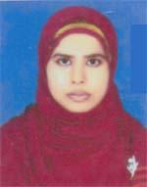 | DR. ASMA AKTER  F/Name: Md. Mofizul Islam Bhuiyan  M/Name: Begum Rehena Islam Bhuiyan  BM & DC Reg. No: 62580  NID: 1594116381351  Cell: 01622589525  Address: Vill-Amtali, Post-Durgapur, Upazilla-Adanaha Sadar, Dist-Comilla  Blood Group: B+
342 | Voter No  LM-1200338 | DR. ABU MOHAMMAD SAEM  F/Name: Mohammad Abdul Haque  M/Name: Farida Haque  BM & DC Reg. No: 41347  NID: 1213314103426  Cell: 01712186304  Address: Akib Mention , Jhawtola, Comilla  Blood Group: AB+
343 | Voter No  LM-1200339  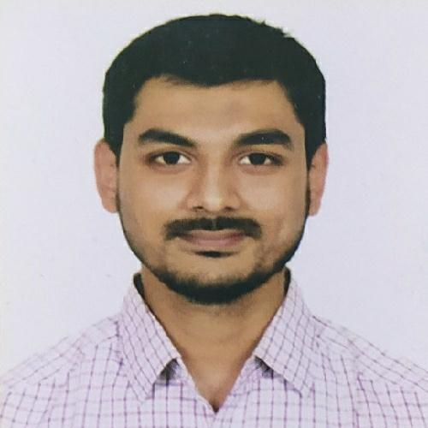 | DR. MD. SIFAT SALEH  F/Name: Dr. M. A. Sattar  M/Name: Mrs. Shahanara Akter  BM & DC Reg. No: 83185  NID: 19911913190000250  Cell: 01733286060  Address: 11A, Comilla Tower, Kandirpar, Comilla.  Blood Group: B+
344 | Voter No  LM-1200340  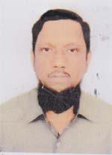 | DR. MD. MAHFUZUL HOQ  F/Name: Azizul Hoq  M/Name: Mahmuda Khatun  BM & DC Reg. No: 11895  NID: 1926712082051  Cell: 01937176718  Address: 593/1, 7B, Karnafuly Park, South Thakurpara, Comilla  Blood Group: B+
345 | Voter No  LM-1200341  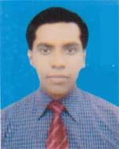 | DR. SAGAR CHAKRABORTY  F/Name: Sanjo Nath Chakraborty  M/Name: Mira Rani Devi  BM & DC Reg. No: 62551  NID: 1916794254833  Cell: 01737165667  Address: Upazilla Health Complex, Adarsha Sadar, Comilla  Blood Group: A+
346 | Voter No  LM-1200342 | DR. RATHIN KUMAR DATTA  F/Name: Ratan Datta  M/Name: Shamoli Rani Datta  BM & DC Reg. No: 62492  NID: 1926705035426  Cell: 01717738911  Address: 240/KA (New), Panpatty, Rajgong, Comilla  Blood Group: A+
347 | Voter No  LM-1200343  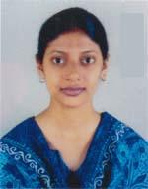 | DR. HASINA AKHTER  F/Name: Mazidul Islam  M/Name: Helen Akter  BM & DC Reg. No: 35463  NID: 1926718125115  Cell: 01817142791  Address: 11C, Sel Sabiha Heights , 181, Jail Road, Police Lane, Comilla  Blood Group: O+
348 | Voter No  LM-1200344 | DR. ABU BAKAR MD. JOBAYER  F/Name: S.m. Eunus Ali  M/Name: Sabura Begum  BM & DC Reg. No: 40381  NID: 1926707049903  Cell: 01720514978  Address: Silver Afia Garden 4D, Doctor Para, Comilla  Blood Group: B+
349 | Voter No  LM-1200345 | DR. JANNATUL FARTHAUS  F/Name: Md. Dildar Hossain  M/Name: Maharun Nessa  BM & DC Reg. No: 75845  NID: 1926710063345  Cell: 01727238601  Address: House No.-118/Kha, Comilla Sadar, 2nd Kasdirpar  Blood Group: O+
350 | Voter No  LM-1200346  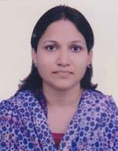 | DR. LIPI PAUL  F/Name: Bidhee Bhushon Paul  M/Name: Bharoti Rani Paul  BM & DC Reg. No: 43389  NID:  Cell: 01716661428  Address: 1159/2, boisuahhi, Eastrace Course, Comilla  Blood Group: A+
351 | Voter No  LM-1200347 | DR. ABU SALAH MD. NAIME  F/Name: Md. Abul Bashar  M/Name: Salina Akter  BM & DC Reg. No: 76153  NID: 1926702006444  Cell: 01722204222  Address: 3C, Ali Rawsan Tower, Fauzdhari More, Comilla  Blood Group: A+
352 | Voter No  LM-1200348 | DR. MD. HOSSAIN AHMED FAIZ CHOWDHURY  F/Name: Md. Forroukh Ahmed Chowdhury  M/Name: Delwara Begum  BM & DC Reg. No: 74604  NID: 1926711076268  Cell: 01717618850  Address: 581, Nimtoli Road, Monohorpur, Comilla  Blood Group: A+
353 | Voter No  LM-1200349 | DR. MD. SHAFIQUR RAHMAN  F/Name: Md. Abdul Latif  M/Name: Nazma Akter  BM & DC Reg. No: 44130  NID: 19811926708057037  Cell: 01716120930  Address: Reaistek (ENT), Comilla Medical College Hospital  Blood Group: B+
354 | Voter No  LM-1200350  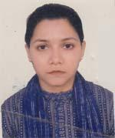 | DR. FARHANA SHARMIN AHMED  F/Name: Monsur Uddin Ahmed Chowdhury  M/Name: Khaleda Khanom Chowdhury  BM & DC Reg. No: 47697  NID: 1923306302977  Cell: 01616843022  Address: Manasins Direetor, Comilla National Hospital, Comilla  Blood Group: O+
355 | Voter No  LM-1200351 | DR. AHMED IRFAN ANWAR  F/Name: Dr. Md. Iqbal Anwar  M/Name: Dr. Nurun Nahar  BM & DC Reg. No: 59557  NID: 1926703012949  Cell: 01678142541  Address: M.O, Adarsha Sadar Upazilla Health Complex, Comilla  Blood Group: A+
356 | Voter No  LM-1200352  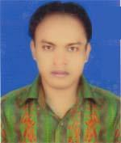 | DR. MD. GOLAM SARWAR  F/Name: Md. Abul Khayer  M/Name: Tahera Begum  BM & DC Reg. No: 46332  NID: 1920902084261  Cell: 01713285539  Address: Holding No. 51, Office Para, Barura Poueoshova, Comilla  Blood Group: O+
357 | Voter No  LM-1200353  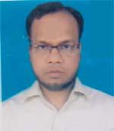 | DR. ABU SAYED MD. SHAHED BILLAL  F/Name: Md. Sarafat Ali  M/Name: Mrs. Dud Naher Begum  BM & DC Reg. No: 42879  NID: 19801910963143416  Cell: 01717661119  Address: Vill-Narayan Pur, Post-Khoshbas, P.s-Barvra, Dist-Comilla  Blood Group: AB+
358 | Voter No  LM-1200354  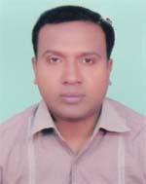 | DR. MOHAMMAD SHAKHAWAT HOSSAIN  F/Name: Mohammad Abdul Latif  M/Name: Mrs. Halima Khatun  BM & DC Reg. No: 32999  NID: 1918711072258  Cell: 01711208842  Address: 8/A (526 Holding) Afia Garden, Doctor Para, Sadar, Comilla  Blood Group: O+
359 | Voter No  LM-1200355  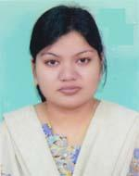 | DR. FARHANA AKTER  F/Name: Sharif Ullah  M/Name: Fatema Khanam  BM & DC Reg. No: 54899  NID: 1916765152009  Cell: 01936213306  Address: Holding No. 526, 8/A Silver Afia Garden, Doctor Para, Badurtala, Comilla  Blood Group: A+
360 | Voter No  LM-1200356 | DR. RISUL ISLAM DIP  F/Name: Rafiqul Islam  M/Name: Shelina Aktar  BM & DC Reg. No: 64699  NID: 1926706040656  Cell: 01770144444  Address: Central Medical College  Blood Group: O+
361 | Voter No  LM-1200357 | DR. PRASENJIT SAHA SHUVA  F/Name: Haripada Saha  M/Name: Tapashi Saha  BM & DC Reg. No: 69784  NID: 19901996712000016  Cell: 01965610869  Address: Pranjal Nibash, 2nd Floor, Panpatti, Rajgonj, Comilla  Blood Group: B+
362 | Voter No  LM-1200358 | DR. A. K. M. KAMRUL AHSAN  F/Name: Abdul Mottalib  M/Name: Late Halima Khatoon  BM & DC Reg. No: 33277  NID: 1926712083047  Cell: 01711390652  Address: North Chartha, Comilla  Blood Group: O+
363 | Voter No  LM-1200359 | DR. MOHAMMED GOLAM GAUS  F/Name: Mohammed Nurul Islam  M/Name: Mosammed Salma Begum  BM & DC Reg. No: 50771  NID: 19791926718000007  Cell: 01740177777  Address: Jhawtala, 222/1, Taher Tread Centre, Kotwali, Comilla  Blood Group: A+
364 | Voter No  LM-1200360  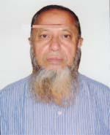 | DR. MD. GYASUDDIN AHMED  F/Name: Late Fazlul Huq  M/Name: Late Saleha Khatun  BM & DC Reg. No: 5719  NID: 1926710068017  Cell: 01711336659  Address: 686/618 KA, 1st Kandir Par, Jhaotala, Comilla  Blood Group: O+
365 | Voter No  LM-1200361 | DR. OMAR AHMED SUMON  F/Name: Dr. Md. Gyasuddin Ahmed  M/Name: Kohinoor Begum  BM & DC Reg. No: 39652  NID: 1926710068412  Cell: 01717005329  Address: H/N-Joshnalaya, 686/618 KA , 1st Kandirpar, Jhaotala, Comilla-3500  Blood Group: O+
366 | Voter No  LM-1200362  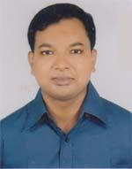 | DR. KHANDAKER MD. ABDUL MUEED  F/Name: Md. Abdul Matin Khandaker  M/Name: Saleha Akhter Chowdhury  BM & DC Reg. No: 57130  NID: 1594116381739  Cell: 01716430855  Address: Holding No. 1004(KA0, South Chartha, Comilla  Blood Group: AB+
367 | Voter No  LM-1200363  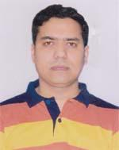 | DR. MOHAMMAD MOSHIUR RAHMAN MAMUN  F/Name: Md. Abdul Khaleque  M/Name: Mrs. Momotaz Begum  BM & DC Reg. No: 44927  NID: 191352544789  Cell: 01713619179  Address: Upazilla Health Complex, Chauddagur, Comilla  Blood Group: AB+
368 | Voter No  LM-1200364  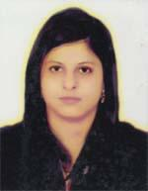 | DR. ALIVA TARIN  F/Name: Md. Rafiqul Alam Khan  M/Name: Mrs. Nargis Khan  BM & DC Reg. No: 73617  NID: 19918192227000133  Cell: 01724668241  Address: Doctor\'s Quater, Upazilla Health Complex, Chouddagram, Comilla  Blood Group: A+
369 | Voter No  LM-1200365  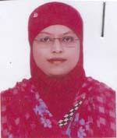 | DR. MST JEMIN AKTER  F/Name: Md. Haqulkatur Rahman  M/Name: Shamsun Nahar Begum  BM & DC Reg. No: 24972  NID: 19692699040000012  Cell: 01816766132  Address: 60/4 west raja bagar, sher-e- bangla nagar dhaka- 1215  Blood Group: A+
370 | Voter No  LM-1200366  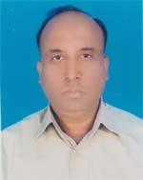 | DR. M. A. SIDDIQ  F/Name: Late Md. Ansar Ali  M/Name: Late Panjatua Nesa  BM & DC Reg. No: 24579  NID: 1927204697451  Cell: 01918474499  Address: Siddiq Medical Centre, Laksam, Comilla  Blood Group: B+
371 | Voter No  LM-1200367 | DR. MOHAMMAD ALI  F/Name: Mohammad Ibrahim  M/Name: Kausari Khanom  BM & DC Reg. No: 26205  NID: 5624609145747  Cell: 01731113340  Address: Department of Medicine, Comilla Medical College Hospital  Blood Group: O+
372 | Voter No  LM-1200368  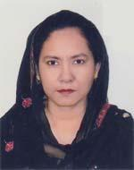 | DR. SHAHELA NAZNEEN  F/Name: Ruhul Amin Chowdhury  M/Name: Tahmina Chowdhury  BM & DC Reg. No: 25433  NID: 2531035762  Cell: 01711176810  Address: 5/E Sel-Nisa Tower, Race Coarce, Comilla  Blood Group: A+
373 | Voter No  LM-1200369  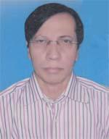 | DR. BASHU DEB DAS  F/Name: Late Saroj Kanti Das  M/Name: Dipali Rani Das  BM & DC Reg. No: 12138  NID: 1910956216475  Cell: 01715019130  Address: Assit. Prof. Community Medicine, Comilla Medical College  Blood Group: B+
374 | Voter No  LM-1200370 | DR. PANCHANAN DAS  F/Name: Mr. Amulya Ranjan Das  M/Name: Mrs. Bulbul Rani Das  BM & DC Reg. No: 26648  NID: 19712691650460468  Cell: 01718331275  Address: 642, Sel Milon Kunja, Fast Talpukur Pan, Comilla, Bangladesh  Blood Group: B+
375 | Voter No  LM-1200371  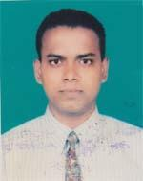 | DR. BABLU KUMAR PAL  F/Name: Dhananjoy Pal  M/Name: Shanti Lata  BM & DC Reg. No: 26915  NID: 2692620332309  Cell: 01915579839  Address: Comilla Medical College, Comilla  Blood Group: A+
376 | Voter No  LM-1200372 | DR. MUHAMMED ANWAR BHUYA  F/Name: Md. Shahadat Husain Bhuya  M/Name: Mrs. Rashida Husain Bhuya  BM & DC Reg. No: 32792  NID: 1927203716588  Cell: 01714080774  Address: Junior Consultant, Nangalkot Upazilla Health Complex, Comilla  Blood Group: O+
377 | Voter No  LM-1200373 | DR. MD. MOHSHIUR RAHMAN CHOWDHURY  F/Name: Late Md. Mokhlesur Rahman  M/Name: Rawshan Ara Akter  BM & DC Reg. No: 26173  NID: 2695041751967  Cell: 01716671991  Address: 1st Floor, Doctor\'s Quarter, General Hospital, Comilla-3500  Blood Group: A+
378 | Voter No  LM-1200374 | DR. MD. ABDUL MOMIN  F/Name: Mr. Md. Aminul Islam  M/Name: Mrs. Khayera Begum  BM & DC Reg. No: 38344  NID: 2154787542525  Cell: 01712132799  Address: 9/C, Comilla Tower  Blood Group: B+
379 | Voter No  LM-1200375  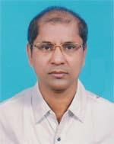 | DR. ABDUL LATIF MOLLA  F/Name: Late Ahmed Hossain Molla  M/Name: Dud Meher Begum  BM & DC Reg. No: 15560  NID: 6720404942780  Cell: 01711046504  Address: Senior Consultant, Comilla Medical College Hospital  Blood Group: O+
380 | Voter No  LM-1200376 | DR. KAMRUN SATTAR  F/Name: Late Md. Abdus Sattar  M/Name: Begum Rokeya  BM & DC Reg. No: 16979  NID: 6720404942781  Cell: 01817565048  Address: Flat No.-9B, Hasna Hena Concord, Arambag, Dhaka  Blood Group: B+
381 | Voter No  LM-1200377 | DR. ZAHIR UDDIN MOHAMMAD BABAR  F/Name: Amir Hossain  M/Name: Late Nilufa Akter Chowdhury  BM & DC Reg. No: 37615  NID: 19762692619475471  Cell: 01721770631  Address: Maa Moni Hospital , Telikona Chowmohani, Chawk Bazar, Comilla  Blood Group: B+
382 | Voter No  LM-1200378  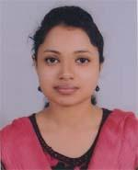 | DR. MOUSHUMI LUCY RAHMAN  F/Name: Alkasur Rahman  M/Name: Shamim Ara Rahman  BM & DC Reg. No: 57243  NID: 1913358313699  Cell: 01715087850  Address: Thikana, Holding No.-916, Bagichagaon South, Comilla-3500  Blood Group: B+
383 | Voter No  LM-1200379  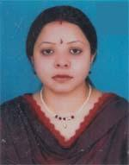 | DR. SUSMITA SEN GUPTA  F/Name: Shankar Sen Gupta  M/Name: Rina Sen Gupta  BM & DC Reg. No: 50797  NID: 2691650140913  Cell: 01711327075  Address: Matui Vandan, Monohorpuri, Comilla-3500  Blood Group: O+
384 | Voter No  LM-1200380  No Image | ***NIL***  F/Name:  M/Name:  BM & DC Reg. No:  NID:  Cell:  Address:  Blood Group:
385 | Voter No  LM-1200381  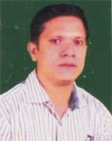 | DR. MINHAZUR RAHMAN  F/Name: Mukhlesur Rahman  M/Name: Nilufar Rahman  BM & DC Reg. No: 40164  NID: 1926708136811  Cell: 01715369580  Address: Nilutpal, 12/7 Kha, 2nd Kandir Par, Comilla  Blood Group: A+
386 | Voter No  LM-1200382  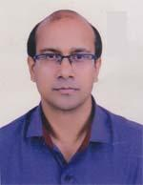 | DR. MOHAMMAD AFTAB UDDIN BHUYAN  F/Name: Mohammad Musleh Uddin Bhuyan  M/Name: Arshadun Nahar  BM & DC Reg. No: 41187  NID: 1926712085884  Cell: 01913259575  Address: 94/87, Bhunnikheton, Diganbaritala, Comilla  Blood Group: O+
387 | Voter No  LM-1200383 | DR. MD. MAHFUGUR RAHMAN  F/Name: A K M Nurul Amin  M/Name: Mrs. Monowara Begum  BM & DC Reg. No: 45318  NID: 2693622425759  Cell: 01928431826  Address: Devidwar. comilla  Blood Group: O+
388 | Voter No  LM-1200384  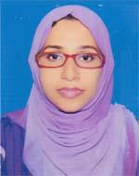 | DR. SHARMIN JAHAN NANCY  F/Name: Abu Tarique  M/Name: Rekha Tarique  BM & DC Reg. No: 66610  NID: 19890695112193995  Cell: 01917147793  Address: Devidwar, Comilla  Blood Group: B+
389 | Voter No  LM-1200385  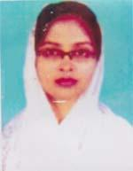 | DR. AFROZA-E-ALAM  F/Name: Md. Khorshed Alam  M/Name: Mst. Rahima Khatun  BM & DC Reg. No: 39707  NID: 2696828674729  Cell: 01717855788  Address: Housing Estate, Comilla, Section-2, Block-C, House-10  Blood Group: B+
390 | Voter No  LM-1200386  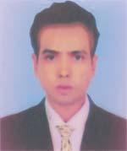 | DR. MD. SHAHED ULLAH  F/Name: Md. Ohab  M/Name: Mrs. Fazilattun Nesa  BM & DC Reg. No: 43877  NID: 1915420193514  Cell: 01717449269  Address: Doctor\'s Quatar, Homna, Comilla  Blood Group: B+
391 | Voter No  LM-1200387  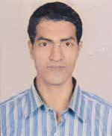 | DR. MD. AKTER ALAM  F/Name: Late Arshed Ali  M/Name: Naytunnessa Begum  BM & DC Reg. No: 27660  NID: 245836585225  Cell: 01712830078  Address: Care Medical Services, Gouripur, Upazilla, Daudkandi, Dist.Comilla  Blood Group: B+
392 | Voter No  LM-1200388 | DR. MD. BELLAL HOSSAIN  F/Name: Abdul Motalib  M/Name: Jusna Begum  BM & DC Reg. No: 46050  NID: 19832694066784809  Cell: 01915453946  Address: Upazilla Health Complex, Homna, Comilla  Blood Group: AB+
393 | Voter No  LM-1200389  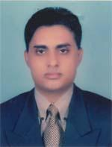 | DR. MD. HELALUR RAHMAN  F/Name: Md. Idrish Miah  M/Name: Sabhia Akter  BM & DC Reg. No: 27969  NID: 1926709058722  Cell: 01711386232  Address: Supanth, House # 52, South Bagicha Gaon (Sardar Bari), Comilla-3500  Blood Group: A+

